**Project[1] Number:** 657227

**Project Acronym:** DoRoThy

**Project title:** Donating Robots a Theory of Mind

**Periodic Technical Report**

**Part B**

**Period covered by the report**: from [01/09/2015] to [31/08/2017]

**Periodic report:** final

# 1. Explanation of the work carried out by the beneficiaries and Overview of the progress

## 1.1 Objectives

### 1.1.1 Summary of the context and overall objectives of the project

Human social dynamics rely upon the ability to effectively attribute beliefs, goals and percepts to other people. This lays at the core of human interactions: normal human social interactions depend upon the recognition of other sensory perspectives, the understanding of other mental states, and the recognition of complex non-verbal cues of attention and emotional state.

With the rapid development of social robotics, meaning robots that interact with humans in usual human environments like homes, transferring these cognitive skills to robots is an important, if difficult, scientific challenge, with a significant societal impact with regard to our future interactions with robots. This scientific endeavour is explicitly set as one of the EU priorities within the Horizon 2020 framework, which emphasizes the need to endow artificial systems with new cognitive capabilities, beyond "repetitive problem solving"[2].

In this context, the DoRoThy project aims first at advancing our **understanding of the complex socio-cognitive mechanisms that underpin human social interactions**, and, second, to investigate **how such mechanisms could by applied to social robots**.

The project has originally a strong emphasise on *mutual modelling*: endowing artificial agents with skills to "read the minds" of others. In effect, in the scientific summary of the DoRoThy project, we underlined how humans exhibit powerful mechanisms to *represent* and *interpret* what others know or intend. DoRoThy originally proposed to build on a *symbolic cognition* paradigm to endow robots with similar social skills.

After an initial period of 6 to 8 months of prototyping, experimentation and consultation with other senior academics at the host institution (see report on WP1 and WP2), we came to the conclusion that a shift of paradigm was required if the project was to have a significant impact on the field.

Therefore, the researcher decided to shift his modelling paradigm from *symbolic cognition* and traditional, logic-based AI techniques, to the **potentially disruptive deep learning techniques**.

To better reflect this change, the titles of work packages have been modified, as indicated below.

* Work Package 1: *Formal Model of Representation-level Meta-Cognition for Robots* becomes *Models of social cognition for human-robot interaction*;
* Work package 2: *Experiment 1: Standard False-Belief Experiment* becomes *Experimental Frameworks for the Study of Social HRI*;
* Work package 3: *Experiment 2: Representation-level Meta-Cognition* becomes *The PInSoRo dataset of Social HRI*;
* Work package 4 is not modified.

## 1.2 Explanation of the work carried per WP

### WP1: *Models of social cognition for human-robot interaction*

The objective of this work package was to design a formal, logic-based, model of theory of mind. **This work package has evolved to investigate a broader model of social cognition, with an accompanying experimental methodology**.

In this section, we report on the work conducted by the researcher to:

1. investigate and frame the specific question of mutual modelling from the complementary perspectives of 3 disciplines (developmental psychology; psychololinguistics; formal epistemology) (task T1.1);
2. integrate these perspectives into a new possible model applicable to Human-Robot Interaction (the *Socio-Cognitive Robotic Awareness Model*) (task T1.2);
3. reframe the original question of mutual modelling into the broader question of *how interactions shape the emergence of social behaviours*, and propose an experimental methodology to investigate this question (T1.3 & T1.4).

**Summary of the deliverables**

|  |  |
| --- | --- |
| D1.1: Publication of a review of relevant literature | Published at HRI2015 (Lemaignan and Dillenbourg 2015) |
| D1.2: Formal model of experiment 1 and 2 | *(no longer applicable, replaced by D1.4)* |
| D1.3: Publication of an experimental methodology to investigate models of social interaction | Publication submitted at HRI2018, under review: (Lemaignan et al. 2018) |

Additional deliverables, not present in the original project:

|  |  |
| --- | --- |
| D1.4: Model of social cognition | The *Socio-Cognitive Robotic Awareness Model*, presented below |

#### Scientific foundations of mutual modelling

The first task T1.1 of WP1 relates to identifying the scientific & interdisciplinary foundations of the theory of mind, as well as the underlying models used in the different discipline.

We report here on the litterature research conducted in three fields (developmental psychology; psycho-linguistics; formal epistemology) where the question of the modelling of the others agents play an important role.

##### Mutual Modelling and Developmental Psychology

###### Connections vs. representations

In (Flavell, Green, and Flavell 1990), Flavell relates perspective taking *Level 1* to establishing *cognitive connections* (I see, I hear, I want, I like, I fear...), in contrast to perspective taking *Level 2* that relates to manipulating *representations*. This is exemplified by *appearance-reality* tasks, like the *elephant mask* experiment proposed in (Flavell, Green, and Flavell 1990): 3-years old children are not able to tell that an experimenter hidden behind a large elephant mask but who speaks normally *looks* like an elephant, *sounds* like the experimenter, and *really is* the experimenter. It appears that, while those children are able to explicitly manipulate cognitive connections (they know for instance that these are largely independent of each other and that they can evolve over time) and know as well that their own connections are independent of those of other people, they do not think that one concept can *seriously* (i.e., non playfully) hold several, possibly conflicting, representations.

This *connection-representation* account appears to be a significant component of a general theory of mind (one needs to recognize that the same object/concept may have different, serious, representations to then accept false beliefs for instance). Fig. 1 illustrates this difference between cognitive connections and representations in an imaginary human-robot interaction scenario. The *visual* perspective of the baby and the mother are represented: a robot endowed with perspective-taking level 1 is able to compute that the baby looks at the plug and the mother looks at the baby. *Representation*-level perspective taking, on the other hand, would require the robot to represent what the socket means to the baby (an attractive affordance), and what the baby’s behaviour represents to the mother (a potential danger).

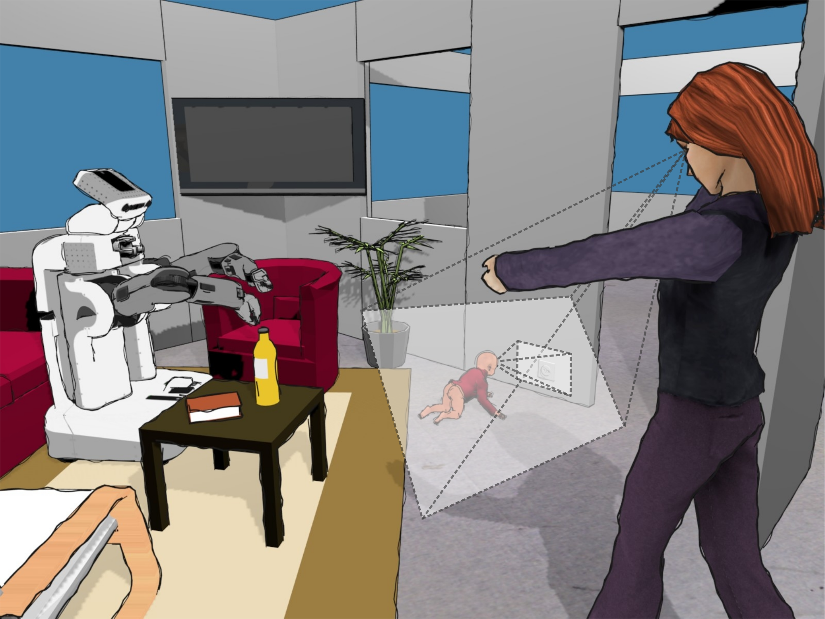

Figure 1: *Visual* perspectives allow for a first level of mutual modelling. However, to correctly comprehend the scene (and for the robot to adequately react, *representation-level* perspective taking is required: what does the power socket means to the baby? What does the situation means to the mother?

##### Developmental pathopsychology

The false belief experiment that we have mentioned above, was proposed by Baron-Cohen in the frame of his research on autistic spectrum disorders (he shows that autistic children seem to actually lack a theory of mind and suggests this as the primary cause of their social impairments), and Frith and Happé further note in  (Frith and Happé 1994) that this specific deficit of autism has led to a large amount of research which proved, in turn, highly beneficial to the study of the development of theory of mind in general. They reference in (Frith and Happé 1994) eight such tasks (tbl. 1), identified during the study of social cognition by autistic children. Each of them is proposed in two versions: one does not require mentalizing, while the other does require it. One of these tasks, for example, required children to distinguish emotions, namely happy/sad faces on one hand (*situation-based* emotion), and surprised faces on the other (*belief-based* emotion) (Baron-Cohen, Spitz, and Cross 1993). Another task, based on the *penny-hiding game*, contrasts the two conditions in terms of *object occlusion* vs. *information occlusion* (Baron-Cohen 1992) (we detail it hereafter). These tasks prototypically illustrate social meta-cognition: one need to represent and reflect on someone else representations (and not only perceptions), and they are not addressed by today’s research on social robots.

Experimental protocols in research on autistic spectrum disorders are often striking by their apparent straightforwardness because of the careful choice of interaction modalities: since autistic children frequently exhibit impairments beyond social ones (such as motor or linguistic ones), the experiments must be designed such that they require only basic cognitive skills beyond the social abilities that are tested. The Sally and Anne task, for instance, requires the observing child to be able to visually follow the marble, to remember the true location of the marble, to understand simple questions (“Where will Sally look for her marble?” in Baron-Cohen’s protocol (Baron-Cohen, Leslie, and Frith 1985)) and eventually to give an answer, either verbally or with a gesture – the two first points being actually explicitly checked through questions: “Where is the marble really?” (reality control question) and “Where was the marble in the beginning?” (memory control question).

Likewise, current social robots have limited cognitive skills (no fast yet fine motor skills, limited speech production and understanding, limited scene segmentation and object recognition capabilities, etc.) and such tasks that effectively test a single cognitive skill (in this case, mentalizing) in near isolation are of high relevance for experimental social robotics.

Table 1: Tasks requiring or not mentalizing to pass, listed by Frith and Happé in (Frith and Happé 1994)

|  |  |
| --- | --- |
| **No mentalizing required** | **Mentalizing required** |
| Ordering behavioural pictures | Ordering mentalistic pictures (Baron-Cohen, Leslie, and Frith 1986) |
| Understanding see | Understanding know (Perner et al. 1989) |
| Protoimperative pointing | Protodeclarative pointing (Baron-Cohen 1989) |
| Sabotage | Deception (Sodian and Frith 1992) |
| False photographs | False beliefs (Leslie and Thaiss 1992) |
| Recognizing happiness and sadness | Recognizing surprise (Baron-Cohen, Spitz, and Cross 1993) |
| Object occlusion | Information occlusion (Baron-Cohen 1992) |
| Literal expression | Metaphorical expression (Happé 1993) |

Frith and Happé’s list (tbl. 1) is in that regard especially interesting in that it mirrors pairs of task (ones which do not require mentalizing with similar ones which do require mentalizing), thus providing control tasks. *Object occlusion* vs. *Information occlusion* is one example of a (pair of) task(s) which evidence representation-level perspective taking through *adaptive deception*: during a simple game, the experimenter adapts its strategy (deceptive/non-deceptive behaviour) to the representation skills of its child opponent. The experimental setting is derived from the penny-hiding game protocol originally proposed by Oswald and Ollendick (Oswald and Ollendick 1989) and replicated and extended by Baron-Cohen in (Baron-Cohen 1992), who describes it as a two-person game in which the subject is actively involved, either as a guesser or as a hider. The hider hides the penny in one hand or the other, and then invites a guess. The game is repeated several time before switching the roles. Baron-Cohen proposes a specific index to rate the level of the players based on the idea of *information occlusion*: minimally, the hider must ensure *object occlusion* (the penny must not become visible to the guesser), while good hiders, with representation-level perspective taking skills, develop strategies (like random hand switching or deictic hints at the wrong hand) to prevent the guesser to find the penny (*information occlusion*). One could imagine a similar protocol adapted to robotics: the robot would play the role of the experimenter, adapting on-line its behaviour to what it understands of the perspective taking capabilities of the children, and would consequently require *second-order*, *representation-level* perspective taking from the robot.

##### Higher-order Theory of Mind

While a great deal of research concerns itself with *first-order* theory of mind, *higher-order* (and particularly, second-order) ToM are also studied. Verbrugge and Mol (Verbrugge and Mol 2008) describe the different levels in the following terms:

To have a first-order ToM is to assume that someone’s beliefs, thoughts and desires influence one’s behavior. A first-order thought could be: *He does not know that his book is on the table*. In second-order ToM it is also recognized that to predict others’ behavior, the desires and beliefs that they have of one’s self and the predictions of oneself by others must be taken into account. So, for example, you can realize that what someone expects you to do will affect his behavior. For example, “(I know) he does not know that I know his book is on the table” would be part of my second-order ToM. To have a third-order ToM is to assume others to have a second-order ToM, etc.

Perner shows in (Perner 1988) that $2^{nd}$-order ToM is mastered around 8 years old, and Flobbe *et al.*propose in (Flobbe et al. 2008) a set of three tasks (a second-order false belief task, a strategic game and a sentence comprehension test) that require second-order mentalizing to succeed. The second-order false belief task that they propose (known as the *Chocolate bar task*) effectively evidence higher-order ToM:

John and Mary are in the living room when their mother returns home with a chocolate bar that she bought. Mother gives the chocolate to John, who puts it into the drawer. After John has left the room, Mary hides the chocolate in the toy chest. But John accidentally sees Mary putting the chocolate into the toy chest. Crucially, Mary does not see John. When John returns to the living room, he wants to get his chocolate.

Flobbe then asks the subjects: *“Where is the chocolate now?”* (reality control question), *“Does John know that Mary has hidden the chocolate in the toy chest?”* (first-order ignorance question), *“Does Mary know that John saw her hide the chocolate?”* (linguistic control question), and *“Where does Mary think that John will look for the chocolate?”* (second-order false belief question). Besides, Flobbe asks the participants to justify their answer (*“Why does she think that?”*). In her study, 82% of a group of 40 children (M=9 year old) successfully passed the task.

While literature on higher-order of mutual modelling is generally scarce, *agreement* and *common belief* is another interesting social situation: Verbrugge (Verbrugge 2009, 664) reports after an experiment by Mant and Perner (Mant and Perner 1988) where a child is disappointed by his father who changed the announced plan to go swimming. In one condition, the child and the father had previously mutually agreed, while in the other, no explicit agreement took place (to a child observer, it actually appears that the situation is **worse** if the child and the father did **not** previously explicitly agree). Children before ten do not distinguish between the two conditions, and Verbrugge’s proposed explanation relies on the concept of *social commitment*, which implies the *common belief* between the two agents that the father *intends* to go swimming and the child is *interested* in going swimming.

Common belief (“we believe that we believe that we believe that... we agreed”) is defined in epistemic logic as an infinite recursion (“ $∞$-order” ToM), and Verbrugge suggests that this mutual modelling mechanism is therefore harder to master for children than 2 ${}^{nd}$-order ToM for instance.

#### Mutual Modelling in Psycholinguistics and Collaborative Learning

Dillenbourg proposes in (Sangin et al. 2007) a model to represent mutual modelling situations. He uses the notation $M\left(A,B,X\right)$ to denote “ $A$ knows that $B$ knows $X$” (equivalent to the epistemic logic notation $K_{A}K_{B}X$ that we present in the next section). This notation does not mean that $A$ has an explicit, monolithic representation of $B$: it must be understood as an abstraction referring to possibly complex socio-cognitive processes. Besides, he refer to the *degree of accuracy* of the model as $M^{∘}\left(A,B,X\right)$.

He parametrizes and assesses the mutual modelling *effort* through 3 variables:

1. Tasks vary a lot with respect to how much they require mutual understanding. The *grounding criterion* (Clark and Wilkes-Gibbs 1986) $M_{min}^{∘}$ refers to how important it is to mutually share a piece of information $X$ to succeed the task $T$. It can be computed as the probability to succeed $T$ despite the fact $X$ is not grounded. $M_{min}^{∘}\left(A,B,X\right)$ can be estimated from the correlation between $M^{∘}\left(A,B,X\right)$ and the task performance.
2. Before any specific grounding action, there is usually a non-null probability that $X$ is mutually understood by $A$ and $B$ (*e.g. $X$* is part of $A$’s and $B$’s cultures, it is manifest to co-present subjects or simply there is not much space for misunderstanding or disagreement about $X$). He notes the theoretical accuracy of initial grounds $M_{t_{0}}^{∘}\left(A,B,X\right)$.
3. The cost of grounding $X$ refers to the physical and cognitive effort required to perform a grounding act $α$: a verbal repair (*e.g.* rephrasing), a deictic gesture, a physical move to adopt one partner’s viewpoint, etc. This cost varies according to media features (Clark and Brennan 1991).

These notations lead to simple representations of mutual modelling during interactions, and Dillenbourg derives several questions out of this model. Adapted to a human-robot interaction situation, fig. 2 (A) represents for instance a dyadic interaction (we use $H$ to denote a human, while $R$ stands for a robot). $Δ_{1}$ illustrates what Dillenbourg calls the *symmetry* question (*Is the accuracy of my model related or not to the accuracy of your model?*).

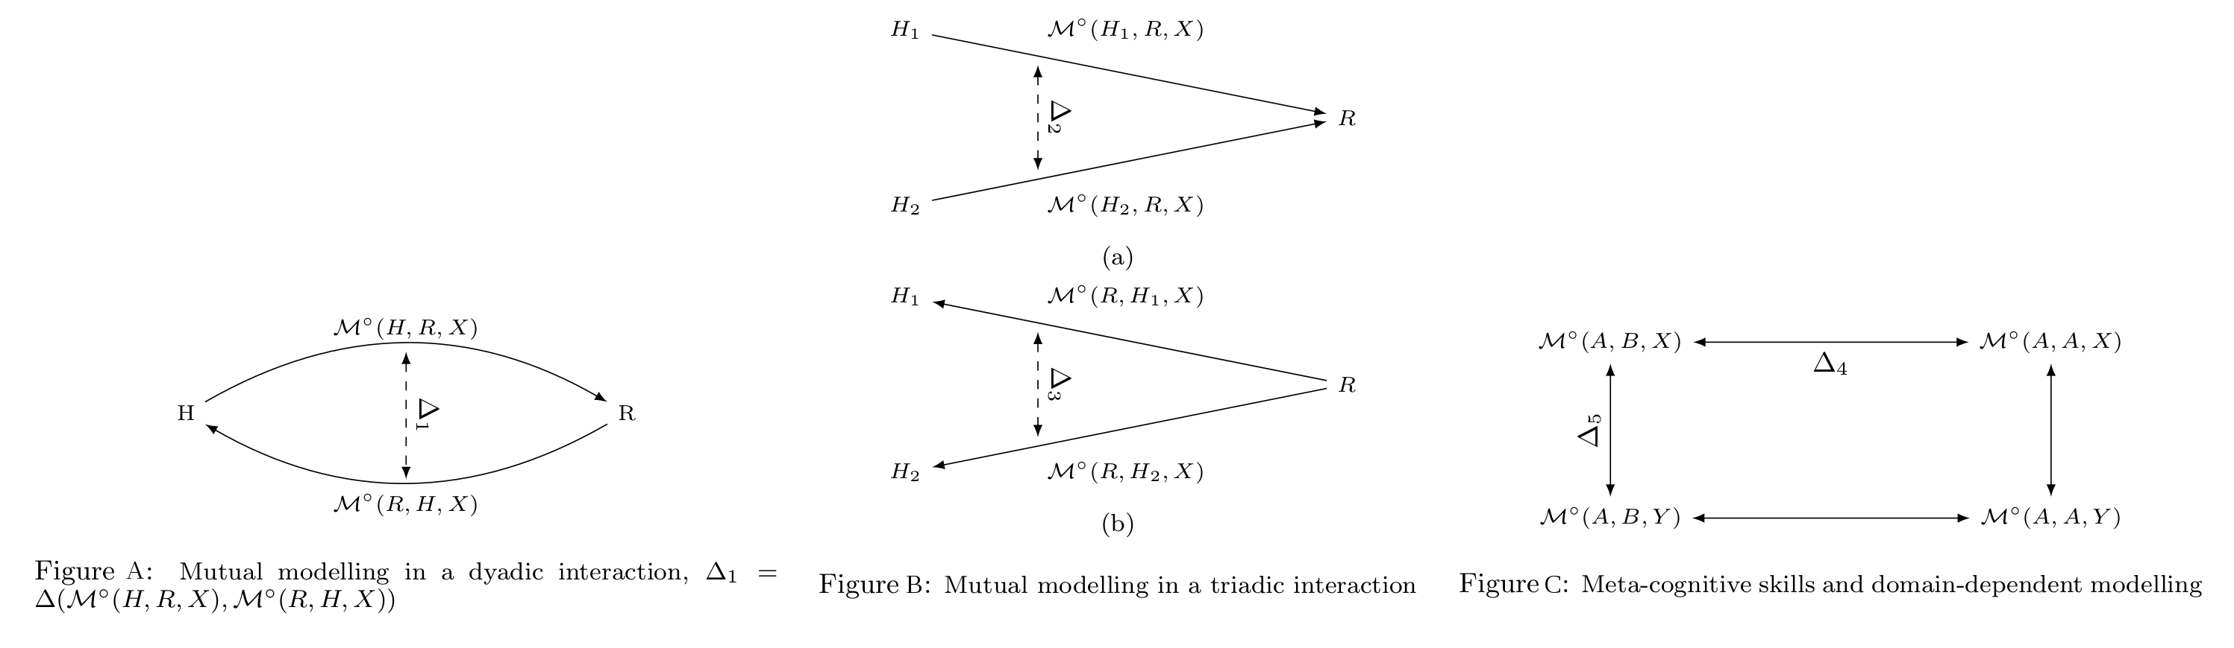

Figure 2: Three levels of mutual modelling proposed by Dillenbourg

With triads (two humans $H_{1}$ and $H_{2}$ and a robot $R$), we may compute the accuracy of 6 models $M^{∘}\left(H_{1},H_{2},X\right)$, $M^{∘}\left(H_{2},H_{1},X\right)$, $M^{∘}\left(H_{1},R,X\right)$, $M^{∘}\left(R,H_{1},X\right)$, $M^{∘}\left(R,H_{2},X\right)$ and $M^{∘}\left(H_{2},R,X\right)$.

This leads to two *triangle questions* relevant to HRI (fig. 2 (B)): Do $H_{1}$ and $H_{2}$ have the same accuracy when modelling the robot $R$? ($Δ_{2}=Δ\left(M\left(H_{1},R,X\right),M\left(H_{2},R,X\right)\right)$), and conversely, what may lead $R$ to model more accurately $H_{1}$ or $H_{2}$? ($Δ_{3}=Δ\left(M\left(R,H_{1},X\right),M\left(R,H_{2},X\right)\right)$).

Finally, Dillenbourg also suggests a *rectangle question*: how self- versus other modelling compares ( $Δ_{4}$ in fig. 2 (C))? This gives an indication of meta-cognitive skills of the agents. We can also question if the modelling skills depend upon what aspects are being modeled ( $X$ or $Y$) which would explain vertical differences ( $Δ_{5}$ in fig. 2 (C)).

This model, designed in the context of human collaboration, evidences questions that are relevant as well to human-robot interactions.

#### Formal Epistemology

The above model of mutual modelling is meant as a practical tool to reason on knowledge dynamics in group interactions and it does not look at being a formal model, whereas formal epistemology, a subfield of the philosophy of mind, focuses on this question.

*Modal logics* look at the formal representation of *possible worlds*, *i.e.*the *possibility* or *necessity* of certain assertions to hold, and is naturally suited to build mathematical representations of situations such as “*the robot knows [the baby may not know what a power socket is]*”.

The *epistemic modal logic* in particular (see (Hendricks and Symons 2008) for an overview and references) focuses on the formal representation of knowledge and beliefs of agents, with the operators $K_{i}φ$ (epistemic operator: agent $i$ knows $φ$) and $B_{i}φ$ (doxatic operator: agent $i$ believes $φ$). Every possible logical propositions belong then to possible *worlds* (noted $w$), that are *accessible* (*i.e.*compatible) or not to one’s beliefs and knowledge.

Single-agent epistemic systems can naturally extend to multi-agent systems (Fagin et al. 1995 chapt. 4): if $p$ stands for “the power socket is dangerous”, $K_{mother}p∧K_{mother}¬K_{baby}p$ states that the mother knows that the socket is dangerous, and also knows that the baby is not aware of this. This provides a formal tool to represent mutual models (the *order* of mutual modelling as discussed in the context of developmental psychology is here directly related to the nesting depth of the epistemic operator).

This approach has led to applications to the representation of knowledge dynamics on concrete, albeit arguably toy, scenarios: van Ditmarsch presents for instance in (Ditmarsch 2002) the formal description of possible Cluedo strategies based on what players know about other players’ knowledge, and along the same line, Verbrugge and Mol analyse mutual modelling in a strategic game with imperfect information (derived from Mastermind) in (Verbrugge and Mol 2008).

Amongst the several *modal operators of knowledge* that have been developed, the *common-knowledge* operator $CK$ is of particular interest. If we define the *shared-knowledge* operator $EK$ as ${EK}_{J}φ↔i∈JK_{i}φ$, *i.e. $φ$* is *shared knowledge* amongst the group $J$ iff every agent in $J$ knows $φ$, then ${CK}_{J}φ↔{EK}_{J}φ∧{EK}_{J}{EK}_{J}φ∧{EK}_{J}{EK}_{J}{EK}_{J}φ∧...$, *i.e. $φ$* is shared knowledge, and it is also shared knowledge that $φ$ is shared knowledge, etc. (this presentation follows (Herzig 2014)). This illustrates how epistemic logic can represent non-trivial social knowledge situations.

Verbrugge further investigates the social aspect of epistemic logics in (Verbrugge 2009) and proposes a survey of epistemic logic applications to *social reasoning*. He underlines both the limits of epistemic logic for that purpose (common epistemic systems assume for instance $K_{i}φ→K_{i}K_{i}φ$, which reads “ $i$ knows $φ$” implies “ $i$ knows that $i$ knows $φ$”, *i.e. $i$* can always introspect, a rather idealized model of human cognition) and the recent advancement towards modelling *human* social cognition, which implies for instance limited rationality. One of these attempts is formalized as a *doxastic epistemic logic* by van Ditmarsch and Labuschagne in (Ditmarsch and Labuschagne 2007), with an explicit focus on modelling *theory of mind* mechanisms. This model builds upon *dynamic epistemic logic* (Ditmarsch, Hoek, and Kooi 2007) (DEL, epistemic logics augmented with mechanisms for knowledge changes), and the modelling of agents’ degrees of belief through a *preference* accessibility relation.

The mathematical objects build from these different modal logics are natural candidates for transposition into representational systems and controllers for robots. Historically in robotics, the main research perspective has been towards the *action logics*, and in particular the influential *situation calculus* (a propositional logic initially proposed by McCarthy, and fully axiomatized in the context of robotics by Levesque *et al.*in (Levesque, Pirri, and Reiter 1998), which led to the golog logic programming language (Levesque et al. 1997)). Many other action logics have been proposed including modal logics like PDL (*Propositional Dynamic Logic*).

Recent efforts have focused on bridging action logics (that deal with *ontic* actions, *i.e.*actions which have tangible, physical consequences) with epistemic logics (that deal with *epistemic* actions, *i.e.*knowledge changes). Van Ditmarsch proposes in (Ditmarsch, Herzig, and De Lima 2010) for instance a solution to embed a practical subset of situation calculus into a dynamic epistemic logic, and Herzig provides in (Herzig 2014) a broader overview of the interplay between current action and epistemic logics.

From a practical perspective however, implementations of these logics into practical reasoners or programming languages remain rare. The development of *Description Logics* (DL) in the knowledge representation community, along with effective, practical tools (like reasoners) is a possible path forward, since DL semantics overlap to some extend with modal logics (Baader et al. 2003, chap. 4.2.2), and *Description Logics* have already been successfully used in robotics (see (Lemaignan 2012) for a review).

#### An initial model of Socio-Cognitive Awareness for robots

As seen in the previous section, symbolic approaches to social cognition work by first building a mental model of the interacting humans. This is typically done by a combination of 3D situation assessment (the robot builds and update a semantic 3D model of its environment) and visual perspective taking (based on the estimation of the pose of the human head). This permits the computation of allocentric, and more importantly, egocentric spatial relations between the spatial entities in the environment (we call it *social situation assessment*). See WP2 for the work done on implementing such a situation assessment module.

This geometric computations are then turned into symbolic representations, typically using logical statements (embedded in logic programming (Tenorth and Beetz 2009) or ontologies (Lemaignan et al. 2010)).

The robot creates and continuously updates one symbolic model per agent (Lemaignan et al. 2010). These models are then used by other cognitive processes (task planning, dialogue, task execution supervision) that are designed to take advantage of the agents’ knowledge models to produce socially-aware behaviours: for example, the task planner may plan manipulation task using only entities visible to the human (Lallement, De Silva, and Alami 2014), or the dialogue manager may use the specific knowledge model of the speaker to interpret the speech, avoiding grounding ambiguities that might otherwise occur (Lemaignan et al. 2011).

This works well as long as we limit ourselves to the manipulation of the results of visual perspective taking. However, one intuitively recognizes that social modelling goes indeed beyond computing what the human perceives or does not perceive. This has been clearly recognized in developmental psychology, for instance with Flavell’s distinction between *cognitive connections* on one hand, and *mental representations* on the other hand. Now, if we are to model someone else’s mind beyond a naive geometric model of their perception, we indeed enter the realm of *representations*. What are they? How to access them? How to represent and manipulate them? These three questions lay at the core of the DoRoThy project, and as such we effectively take over the point we previously made in (Lemaignan and Dillenbourg 2015): we ultimately want to come up with a meta-representational cognitive system to *represents representations* (including representations of *false* beliefs or unknown facts, i.e. suppositions).

We must immediately clarify that, even though this goal may seem to pre-suppose *symbolic* meta-representations, this is not the case: at that stage, we do not have evidence that a particular kind of computational structure may better support the representation and manipulation of mental representations.

###### From Social Attention to Social Modelling: the Attention Schema Theory

##### Phenomenal *vs.* Access Consciousness

The neuroscientist view proposed by Block comprises of two kind of consciousness (Block 1996): *phenomenal* consciousness as the raw inner experience; *access* consciousness as the more abstract, cognitive ability to think about and report on those experiences.

We map in our model these two kind of consciousness to the traditional sub-symbolic/symbolic divide that we observe in artificial intelligence, and in particular in robotics. The *phenomenal consciousness* is the immediate, raw perceptual inputs: video streams from cameras, readings for torque and force sensors, joint positions, etc. The *access consciousness* is the symbolic, abstract representation of these inputs. We must however keep in mind that there is likely no such rigid dichotomy between phenomenal consciousness and access consciousness. It is rather a continuum of processing (Graziano 2013, 55)

The hypothesis that we hereafter develop and turn into a cognitive model is the following: **mental representations are snapshots of awareness, awareness being itself a label for the memory-mediated process of attention**.

This extends to social cognition: **modelling others’ mental representations is taking snapshots of their current state of awareness**. As we do not have direct access to others’ process of attention, it has to be mediated. We suggest that **modelling other’s state of awareness is mediated by one’s own attentional system, through joint attention mechanisms**.

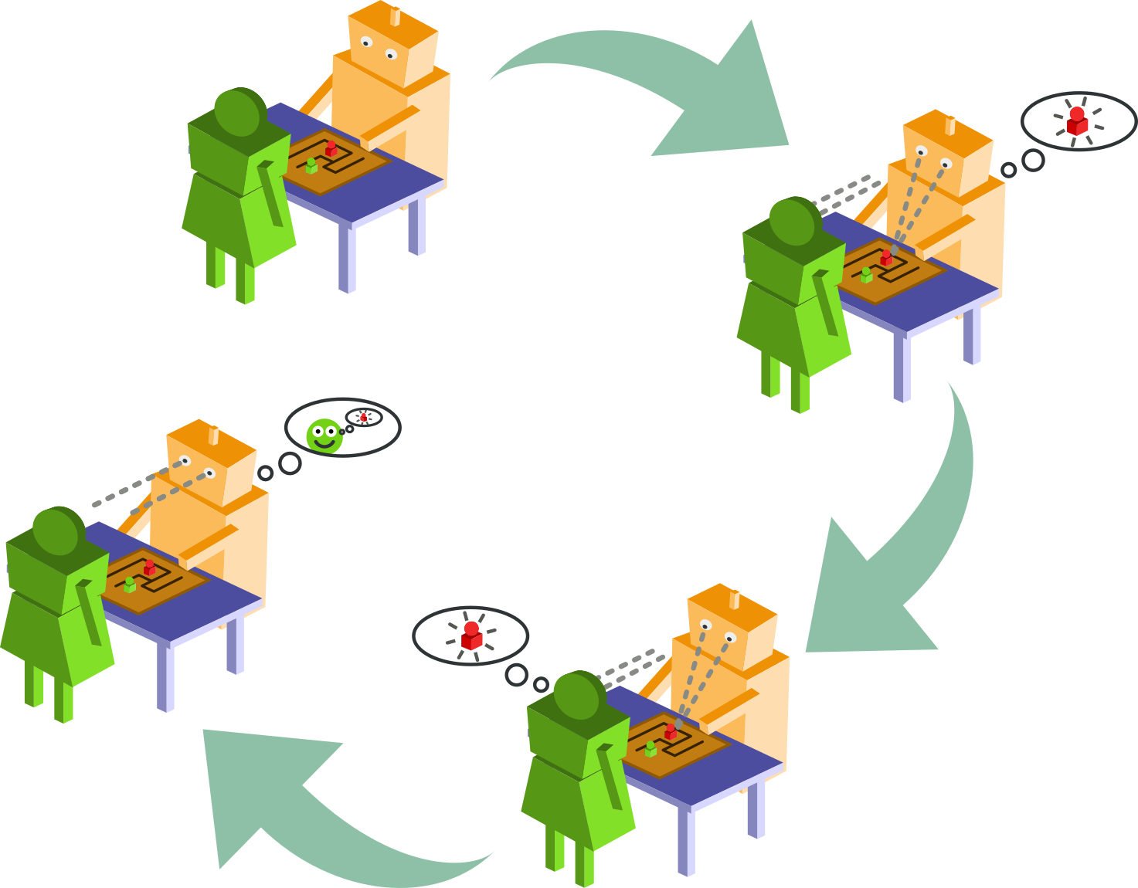

Figure 3: Illustration of the Social Awareness model

Our approach draws form the *Attention Schema Theory* (fig. 3), proposed by Grazino (Graziano 2013). We use an *associative memory network* as an *Informational Proxy* for the attention system and we postualte that **modeling one other mental representations equates to taking snapshots of their current state of awareness**.

As we do not have direct access to others’ process of attention, it has to be mediated. Following Graziano, we hypotesise that **modelling other’s state of awareness is mediated by one’s own attentional system, through joint attention mechanisms**:

1. **mental representations** are **snapshots of what we are aware of**
2. **awareness** is the label we conveniently put on the **process of attention**
3. attention at time t is the label we put on the set of the **activated units** in a (biased) **associative memory network**
4. modelling **others’ mental representations** is taking snapshots of their own current state of awareness
5. modelling other’s state of awareness, their current attentional process, is **mediated by one’s own attentional system**, typically through **joint attention** mechanisms
6. Points 1 to 5 essentially refer to a *phenomenal* awareness (a *raw* inner experience). *Phenomenal* awareness can be turned into *access consciousness* (the abstract, cognitive ability to reflect on the inner experience)
7. In AI, *phenomal awareness* maps to connectionist approaches, while *access consciousness* maps to **symbolic representations**

The attention itself is modelled as a *Biased Competition Model of Attention* (Desimone and Duncan 1995) that can be implemented using a particular *Associative Memory Network* with an additional top-down biasing mechanism. Such associative memory networks have been extensively discussed by the researcher with P. Baxter, researcher at the host institution.

One of the results of these discussions is a efficient re-implementation of Baxter's model of associative memory (Baxter et al. 2012), fig. 4. The link to the corresponding open-source code repository is available in the appendices.

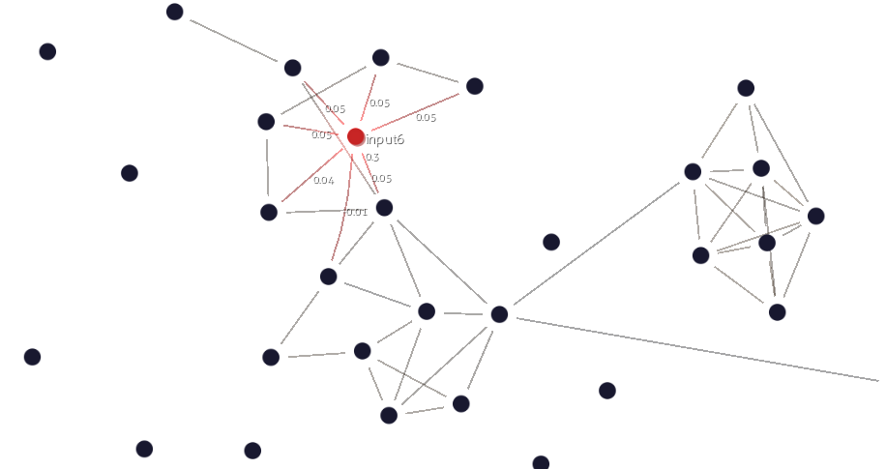

Figure 4: Visualisation of an associative memory network. New implementation by the researcher based on (Baxter et al. 2012)

This model of *social awareness* for the robot is remained at the stage of a theoretical idea, and after further discussions with other senior academics at the host institution, the researcher has decided to shift the reseach focus towards a more concrete investigation of the dynamics of the social interactions, with possibly machine-learning applications in mind.

#### A conceptual framework to studying social interactions

Studying social interactions requires a social *situation* that effectively elicits interactions between the participants. Such a situation is typically scaffolded by a social task, and consequently, the nature of this task influences in fundamental ways the kind of interactions that might be observed and analysed. In particular, the socio-cognitive tasks commonly found in the literature of experimental psychology (and HRI) often have a narrow focus: because they aim at studying one (or a few) specific social or cognitive skills in isolation and in a controlled manner, these tasks are typically simple and highly constrained (for instance, an object hand-over task; a perspective-taking task with cubes, etc.). While these focused endeavours are important and necessary, we – as a community – also acknowledge that these interaction scenarios do not reflect the complexity and dynamics of real-world interactions (Baxter et al. 2016), and we certainly observe a strong trend within our community towards capturing, interpreting and acting upon the rich set of naturally-occurring social interactions.

Specifically, we believe that further progress in the study of human-robot interactions should be scaffolded by socio-cognitive challenges that:

* are long enough and varied enough to elicit a large range of interaction situations;
* foster rich multi-modal interaction, such as simultaneous speech, gesture, and gaze behaviours;
* are loosely directed, to maximise natural, non-contrived behaviours;
* evidence complex social dynamics, such as rhythmic coupling, joint attention, implicit turn-taking;
* include a certain level of non-determinism and unpredictability.

The challenge lies in designing a social task that exhibits these features *while maintaining ‘good’ scientific properties* (repeatability, replicability, robust metrics) as well as good practical properties (not requiring unique or otherwise very costly experimental environments, not requiring very specific hardware or robotic platform, easy deployment, short enough experimental sessions to allow for large groups of participants).

In the frame of the DoRoThy project, the researcher has developed such a novel social sitation, presented in details in WP2. This new paradigm builds on *social play*.

##### Social play

Our interaction paradigm is based on free and playful interactions (free play) in a *sandboxed* environment: while the interaction is free (participants are not directed to perform any particular task beyond playing), the activity is both *scaffolded* and *constrained* by the setup mediating the interaction (essentially, a large table-top touchscreen). Participant engage in open-ended and non-directive play situations, yet sufficiently well defined to be reproducible and practical to record and analyse.

This initial description frames the socio-cognitive interactions that might be observed and studied: playful, dyadic, face-to-face interactions. While gestures and manipulations (including joint manipulations) play an important role in this paradigm, the participants do not typically move much during the interaction. Because it builds on play, this paradigm is also naturally suited to the study of child-child and child-robot interactions.

The choice of a playful interaction is supported by the wealth of social situations and social behaviours that *play* elicits. Most of the research in this field builds on the early work of Parten who established five *stages of play* (Parten 1932), corresponding to different stages of development, and accordingly associated with typical age ranges:

1. **Solitary (independent) play**, age 2-3: Playing separately from others, with no reference to what others are doing.
2. **Onlooker play**, age 2.5-3.5: Watching others play. May engage in conversation but not engage in doing. True focus on the children at play.
3. **Parallel play** (adjacent play, social co-action), age 2.5-3.5: Playing with similar objects, clearly beside others but not with them (near but not with others.)
4. **Associative play**, age 3-4: Playing with others without organization of play activity. Initiating or responding to interaction with peers.
5. **Cooperative play**, age 4+: Coordinating one’s behavior with that of a peer. Everyone has a role, with the emergence of a sense of belonging to a group. Beginning of “team work.”

These five stages of play have been extensively discussed and refined over the last century, yet remain remarkably widely accepted as such. It must be noted that the age ranges are only indicative. In particular, most of the early behaviours still occur at times by older children.

Interestingly, these five stages can been looked at from the perspective of HRI as well. They evoke a roadmap for the development of human-robot social interactions that forms the theoretical background of the free play sandbox paradigm, detailed in the next section.

### WP2: *Experimental Frameworks for the Study of Social HRI*

The original objective of this work package was to develop the required software to reproduce the standard *false-belief* task (*Sally and Anne* task) on the Nao robot.

The work package has evolved: following initial investigations (reported here after), the researcher has focused his investigations on the **design of a novel experimental framework to investigate social interactions**, both for human-human interactions, and human-robot interactions.

In this section, we report on the work conducted by the researcher to:

1. develop new hardware and software to endow the Nao robot with depth vision and accurate gaze tracking (task T2.2);
2. develop a situation assessment tool to perform geometric reasoning and compute visual perspectives (task T2.3);
3. design and implement a novel methodology to investigate social interactions, well suited for deep-learning applications (includes task T2.2)

Additional work, including 2 experiments (D2.7 and D2.8), have been carried by the researcher. Refer to the list of additional deliverables below.

Note that task T2.1 (*adapt oro knowledge base to Nao*) and task T2.4 (*run the experiment*) are no longer relevant, following the project's refocus.

**Summary of the deliverables**

|  |  |
| --- | --- |
| D2.1: Open-source software for sitation assessment | The underworlds software project, publication submitted at HRI2018, under review: (Lemaignan, Papadopoulos, and Belpaeme 2018) |
| D2.2: Experiment 1 | *(no longer applicable, replaced by* *WP3* |
| D2.3: Publication of experiment 1 results | *(no longer applicable, replaced by* *WP3* |

Additional deliverables, not present in the original project:

|  |  |
| --- | --- |
| D2.4 | Open-source hardware to provide Nao with RGB-D vision |
| D2.5 | Organisation of a workshop on attention tracking during the 2016 HRI Summer School |
| D2.6 | Publication of an robotic software architecture that take into account human perspectives (S. Lemaignan, Warnier, et al. 2016) |
| D2.7 | Novel experimental methodology to investigate natural social interaction (source code available; publication under review: (Lemaignan et al. 2018)) |
| D2.8 | Experiment to assess the quality of speech recognition on Nao (Kennedy et al. 2017) |
| D2.9 | Experiment to assess the social presence of humanoid robots (publication under review: (Irfan et al. 2018)) |

#### Situation Assessment for the Nao robot

As sketched in (Lemaignan and Dillenbourg 2015) and (S. Lemaignan, Warnier, et al. 2016), endowing robots with *visual perspective taking* abilities is a pre-requisite to build further, more advanced, models of others' mental state.

In the frame of DoRoThy, the researcher has developped a novel software framework for geometric reasoning and situation assessment that introduce a new concept of *cascading worlds*. This open-source framework is called Underworlds (task T2.3, deliverable D2.1).

Besides, to make it usable on a Nao robot, the researcher designed and made publicly available a 'hat' for Nao, embedding a RGB-D camera.

##### Underworlds

underworlds ((Lemaignan, Papadopoulos, and Belpaeme 2018), under review) is a distributed and lightweight open-source framework[3] that enables robot programmers to build and refine spatial and temporal models of the environment surrounding a robot in real-time. underworlds makes it possible to share these world models amongst the software components running on the robot. Additionally, underworlds enables users to represent and manipulate *multiple alternatives* to the current, perceived world model in a distributed manner. For instance, the world with some objects filtered out; the world ‘viewed’ from the perspective of another agent; a hypothetical world resulting from the simulated application of a plan, etc.

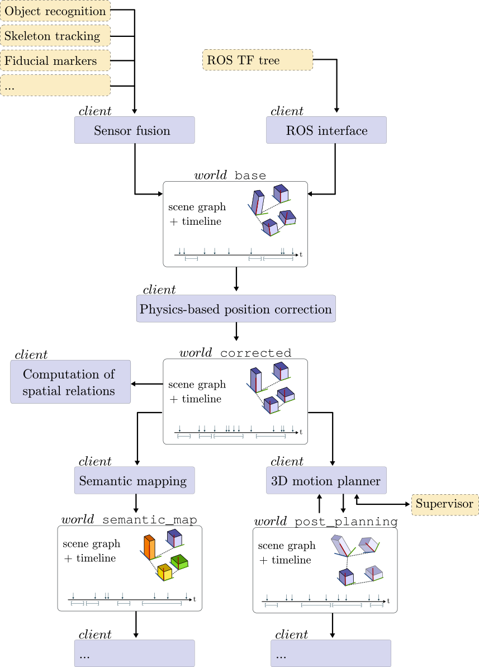

Figure 5: Schema of a possible underworlds network: eight *clients* (user-written & architecture specific; in blue) are sharing environment models through four independent *worlds* (made from joint spatial and temporal models). This architecture enables successive and modular refinement of the models (*cascading* situation assessment), effectively adapted to each client’s needs. *Dashed yellow nodes represent other possible components in the system that do not interact directly with the underworlds network*.

fig. 5 pictures a typical underworlds topology: a graph (that happens to be a directed acyclic graph on fig. 5, but does not have to be in the general case – cycles are permitted) of *clients* connected through shared data structures called *worlds*.

###### Clients

Software components accessing underworlds worlds are called clients. Some standard clients (like a 3D visualisation tool) are provided with the underworlds package. Clients are otherwise written by the end users using the underworlds client API.

Clients can both read and write onto the worlds they are connected to, and automatically see updates broadcast by other clients connected to the same world.

Four specific types of clients can be distinguished: **root clients** which create and update worlds (‘write-only’ client, like the *Sensor fusion* and *ROS interface* clients in fig. 5); **leaf clients** which on the contrary only read worlds, without modifying them (like the *Computation of spatial relations* client on fig. 5); **filters** that copy an input world into an output world, performing some filtering operation in-between (like the client *Physics-based position correction*); and **transformers** which transform one representation into another (like the *Semantic mapping* client on fig. 5).

###### Worlds

Worlds are effectively distributed data structures composed of a scene graph representing the 3D geometry of the environment, and a timeline storing temporal events.

Each world is technically independent from all others. Dependencies between worlds arise from the clients’ connections. For instance, filters effectively create a dependency between worlds. On fig. 5, the *Physics-based position correction* client creates a dependency between the world base (which represents here the result of raw sensor fusion) and the world corrected which would be a physically-consistent copy of base. As a result, an underworlds network can be seen as a dependency graph between worlds (where cyclic dependencies are permissible).

This architecture enables what we call *cascading situation assessment*: independent software components (the clients) build, refine and share successive models of the environment by a combination of filtering/transformations steps and model branching.

###### Scenes

Worlds contain both a geometric model and a temporal model. The geometric model is represented as a scene graph. The scene graph has a unique root node, to which a tree of other nodes is parented.

Nodes in an underworlds scene graph have four possible types: **objects** that represent concrete physical objects (typically with one or several associated 3D meshes); **entities** that represent abstract entities like reference frames or groups of objects; **perspectives** that represent viewpoints of the scene (like cameras or human gaze); and **fields** that represent scalar or vector fields (like the visibility of an object, the working space of robot, etc.

Every node has a unique ID, a parent, a 3D transformation relative to the parent and an optional name. *Object* nodes optionally store as well pointers to their associated meshes. Importantly, mesh data (or other geometric datasets like point clouds) are *not* stored within the nodes themselves. underworlds represents geometric data as immutable data, identified by their hash value (preventing *de facto* data duplication). Nodes only store the hash corresponding to the desired geometric data, and the actual data is pulled from the server by the clients whenever they actually need it (for rendering for instance).

###### Timelines

Complementing the spatial representation encapsulated in the scene graph, each world also stores the world’s *timeline*. This data structure is shared and synchronised amongst the clients in the same way as the scene graph. Clients can record both *events* (duration-less states) and *situations* in the timeline, i.e., states with a start time and a (possibly open-ended) end time.

Importantly, the underworlds server automatically generates a snapshot of the scene graph whenever an event or situation is added to the timeline. The snapshot is associated to the event, which allows clients to effectively retrieve past states of the world. This capability is anticipated to be primarily used by underworlds clients performing action recognition.

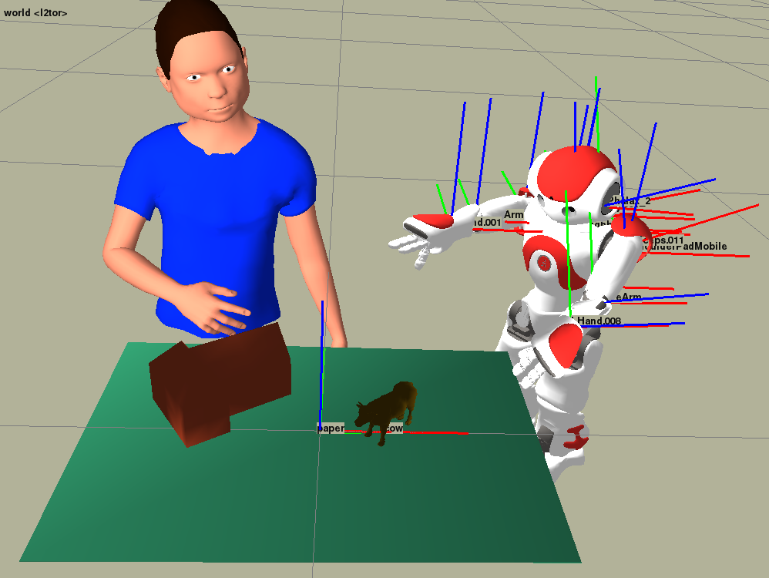

Figure 6: Screenshot of the uwds view 3D visualisation and manipulation client. In this particular example, the 3D meshes have been pre-loaded using uwds load. Their positions are then updated at run-time using the robot’s sensors and proprioception (joint state).

###### Distributed spatio-temporal models

underworlds is not a monolithic piece of software. Instead, it stands for both a *network of interconnected clients* which manipulate spatial and temporal models of the robot environment (for instance, a motion planner, a object detection module, a human skeleton tracker, etc.), and for a client library that makes it possible to interface existing software components with the network.

Critically, the network is essentially hidden to the client: from the user perspective, the environment model is manipulated as a local data structure. Modifications to the model are asynchronously synchronised with a central server (the underworlded daemon) and broadcast to every other client connected to the same world. As previously mentioned, worlds are composite data structures comprised of a scene graph and a timeline. These data structures are synchronised using Google’s gRPC message passing framework[^2], ensuring high throughput, reliability and cross-platform/cross-language support.

underworlds is meant to broadcast complex environment representations (typically including large geometric datasets, like meshes) in real-time. underworlds itself does not perform many CPU intensive tasks (CPU intensive processing tasks – sensor fusion, physics simulation, etc. – are performed by the clients themselves) and as such, the performance bottleneck is essentially the network’s data throughput. In that regard, one of the simple yet critical optimisations performed by underworlds is automatic caching of mesh data. Mesh data are not transmitted when nodes are updated; only a hash value of the mesh data. The client can then request the full data whenever it is actually needed.

###### Spatial Reasoning and Perspective Taking

Spatial reasoning (O’Keefe 1999) is a field in its own right, and has been used for natural language processing for applications such as direction recognition (Kollar et al. 2010; Matuszek, Fox, and Koscher 2010) or language grounding (Tellex 2010). Other examples in human-robot interaction include Ros et al. (Ros et al. 2010b; Ros et al. 2010a) which has recently been integrated into a full architecture for autonomous human-robot interaction (S. Lemaignan, Warnier, et al. 2016).

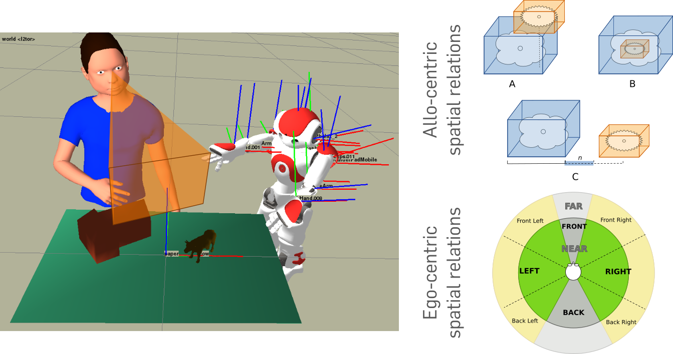

Figure 7: The spatial_relations client computes perspective-aware spatial relations between objects and agents: *allo-centric* relations (like is in or is on) are independent of the viewpoint, while *ego-centric* relations (in front of, left of) depend on the viewer perspective.

underworlds provides a client (spatial_relations) to compute both allo-centric and ego-centric (i.e., viewer-dependent) spatial relations between objects (Figure fig. 7).

underworlds also implements an efficient algorithm to assess object visibility from a specific viewpoint (i.e., from a given *perspective* node). The algorithm (color picking) enables fast (single pass) computation of the visibility of every object in the scene, while providing control regarding how many pixels should be actually visible for the object to be considered globally visible. The command-line tool uwds visibility returns the list of visible objects from the point of view of each camera in a given world, and underworlds also provides the helper class VisibilityMonitor to programmatically access visibility information.

When integrated into a filter node, visibility computation allows easy creation of new worlds representing the estimated perspectives of the different agents. lst. 1 provides the complete code of such an underworlds client.

Listing 1: Example of use of underworlds to extract the visual perspective of one human

import copy  
import underworlds  
from underworlds.tools.visibility import VisibilityMonitor  
  
with underworlds.Context("Human PoV") as ctx:  
  
 source = ctx.worlds["base"]  
 target = ctx.worlds["human_perspective"]  
  
 # pick up the first node named 'human'  
 human = source.scene.nodebyname("human")[0]  
 target.scene.nodes.append(human)  
  
 # VisibilityMonitor computes the set of visible   
 # nodes from a given viewpoint  
 visibility = VisibilityMonitor(ctx, source)  
  
 node_mapping = {}  
  
 while True:  
  
 for node in visibility.from_camera(human):  
  
 newnode = node.copy()  
  
 # track the correspondence between nodes  
 # in source and target scenes  
 if node in node_mapping:  
 newnode.id = node_mapping[node].id  
 else:  
 node_mapping[node] = newnode  
  
 # reparent the nodes to the new root  
 if node.parent == source.scene.rootnode.id:  
 newnode.parent = target.scene.rootnode.id  
  
 target.scene.nodes.update(newnode)  
  
 source.scene.waitforchanges()

###### Application to the L2TOR H2020 project

Due to the change of focus of the project, underworlds has not been directly put to use in the frame of DoRoThy.

However, underworlds has been used within the H2020 L2TOR project (led by the host institution) in order to conceptualise and visualise the spatial relations and visibility of the physical objects that participants interact with. In one of the scenarios of this project, participants are instructed by a NAO robot to manipulate a number of Duplo-like animals on top of a printed background paper which serves as a landscape (fig. 8). The robot instructions are based on pedagogical strategies to promote spatial relation learning by object manipulation. Such instructions include commands to place the elephant *on top* or *next to* the cube, or put the giraffe *inside* the house. To assess the performance, the robot and the operator need to compute spatial relationships between objects from the visual perspective of the participant.

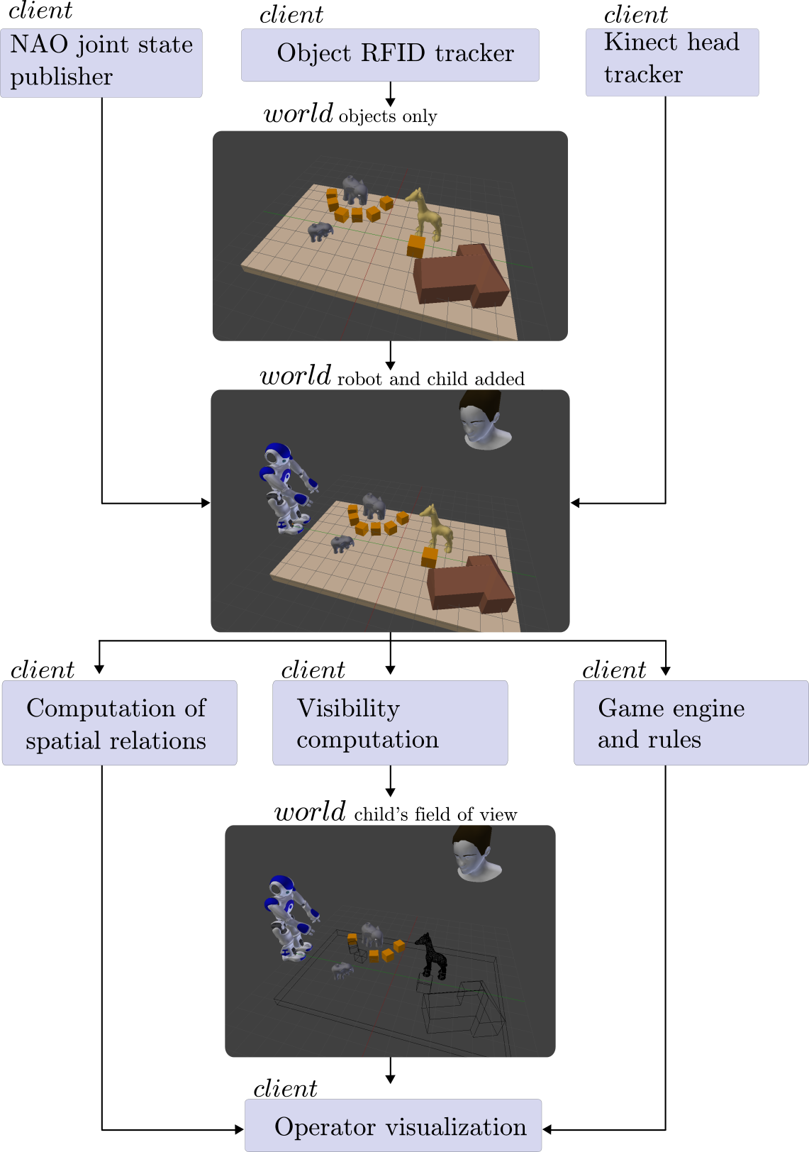

Figure 8: Schema of the underworlds architecture used in the H2020 L2TOR project

##### RGB-D vision for the Nao robot

Because the typical sensory input required to feed in underworlds worlds (3D map of the environment and humans) require a RGB-D camera, not available on the Nao robot, the researcher designed and build a 'hat' for the robot, able to embed a 3D Intel Realsense F200 (or SR300) camera (fig. 9).

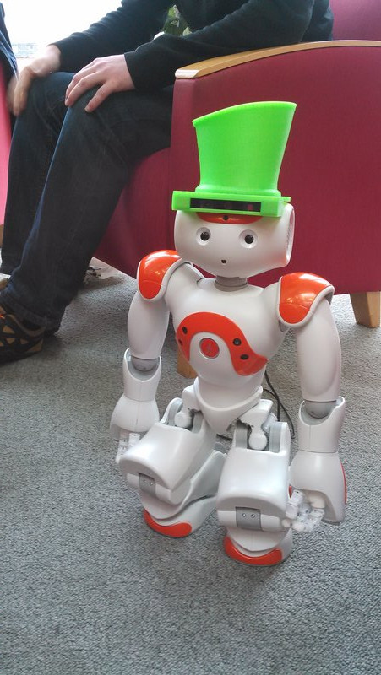

Figure 9: 3D printed hat, design to hold a RGB-D camera on the head of a Nao robot

3D models required to 3D print the hat and detailed assembly instruction have been made available online: [github.com/severin-lemaignan/nao-magic-hat](https://github.com/severin-lemaignan/nao-magic-hat)

#### Freeplay sandbox

Evaluating human-robot social interactions in a rigorous manner is notoriously difficult: studies are either conducted in labs with constrained protocols to allow for robust measurements and a degree of replicability, but at the cost of ecological validity; or *in the wild*, which leads to superior experimental realism, but often with limited replicability and at the expense of rigorous interaction metrics.

In the frame of the DoRoThy project, the researcher has **conceptualised, designed, implemented and applied a novel interaction paradigm**, designed to elicit rich and varied social interactions while having desirable scientific properties (replicability, clear metrics, possibility of either autonomous or Wizard-of-Oz robot behaviours). This paradigm focuses on child-robot interactions, and builds on a *sandboxed free-play environment*.

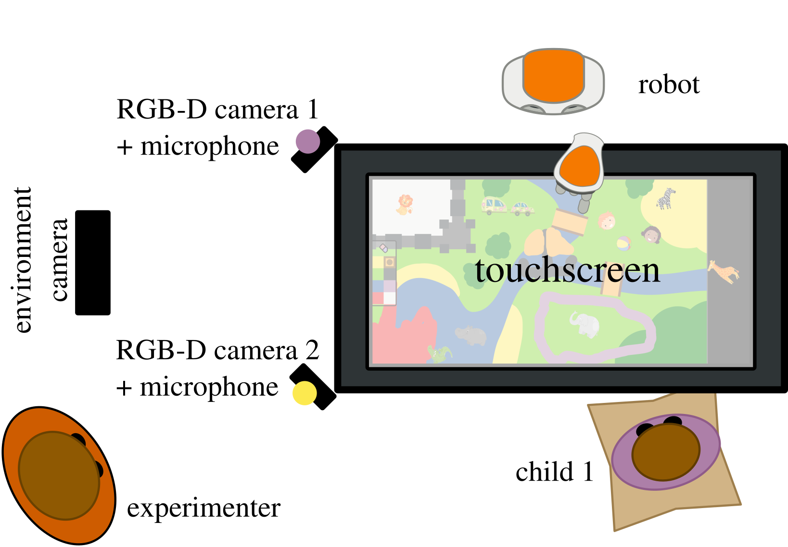

Figure 10: The free-play social interactions sandbox: two children interact in a free-play situation, by drawing and manipulating items on a touchscreen. Children are facing each other and sit on cushions. Each child wears a bright sports bib, either purple or yellow, to facilitate later identification.

##### Task

We have designed a new experimental task, called the *free-play sandbox*, that is based on free play interactions. Pairs of children (4-8 years old) are invited to freely draw and interact with items displayed on an interactive table, without any explicit goal set by the experimenter (fig. 10). The task is designed so that children can engage in open-ended and non-directive play, yet it is sufficiently constrained to be suitable for recording, and allows the reproduction of social behaviour by an artificial agent in comparable conditions.

The free-play sandbox follows the sandtray paradigm (Baxter, Wood, and Belpaeme 2012): a large touchscreen (60cm $×$ 33cm, with multitouch support) is used as an interactive surface (*sandtray*). Two children play together by freely moving interactive items on the surface (fig. 11). A background image depicts a generic empty environment, with different symbolic colours (water, grass, beach, bushes...). By drawing on top of the background picture, the children can change the environment to their liking. The players do not have any particular task to complete, they are simply invited to freely play. Importantly, they can play for as long as they wish (for practical reasons, we have limited the sessions to a maximum of 40 minutes in our own experiments).

Capturing all the interactions taking place during the play sessions is possible and practical with this setup. Even though the children will typically move a little, the task is fundamentally a face-to-face, spatially delimited, interaction, and as such simplifies the data collection. For instance, during our dataset acquisition campaign (120 children, more than 45h of footage), the children’s faces were automatically detected in 98% of the recorded frames.

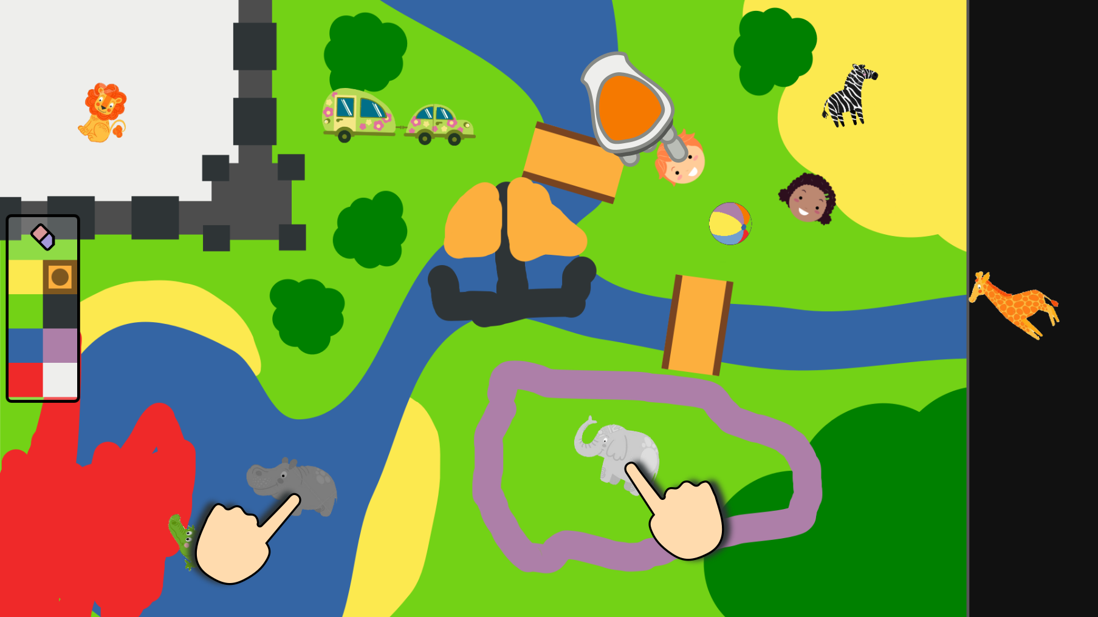

Figure 11: Example of a possible game situation. Items (animals, characters...) can be dragged over the whole play area, while the background picture can be painted over by picking a colour.

##### Applications

###### Child-Child Interaction

The free-play sandbox provides the opportunity to observe children interacting in a natural way in an open but framed setup. As the system can run on a single computer platform it can easily be deployed in the ’wild’, in places where the children naturally interact such as classroom. The quantity and thoughtfulness of information logged allows to keep a track of every interaction happening around the game.

These advantages combined with the openness of the task proposed make this setup a powerful tool to observe and quantify a large spectrum of social behaviours expressed by children when interacting in a natural environment. The compactness of the system makes it easy to compare data from different locations.

###### Child-Robot Interaction

This free-play sandbox provides the opportunity to explore child-robot interactions in this open, real world environment as shown in fig. 10.

Depending of the focus of the study, two modes of control for the robot are available. If the interest is on evaluating a specific robot behaviour, the robot can be autonomously controlled using inputs from the different sensors. This setup allows to explore the impact of different social behaviours on the children independently of the ‘game policy’ controlling by the robot.

On the other hand, if the focus is on the child behaviour and the technical aspect is of a lower importance, the robot can be controlled by a human rather than an algorithm. This paradigm, where the robot is tele-operated to interact with a naive partner is called Wizard of Oz (WoZ) and is used in numerous studies to explore the psychologic side of HRI (Riek 2012).

###### Deep Learning

With the quantity of data logged and the high number of interaction achievable with the free-play sandbox, it supports the type of requirement for recent Machine Learning approaches such as deep learning. The similar position of the children in all interactions makes the combination of data from different interaction easier than other less compact systems.

From the information collected on the children, social behaviours can be extracted and used on a robot.

##### Implementation

The software-side of the free-play sandbox is entirely open-source[^1]. It is implemented using two main frameworks: Qt QML[^2] for the graphical interface of the game, and the *Robot Operating System* (ROS) for the modular implementation of the data processing and behaviour generation pipelines. The graphical interface interacts with the decisional pipeline over a bidirectional QML-ROS bridge that we have developed for that purpose.

Fig. 12 presents the software architecture of the sandbox.

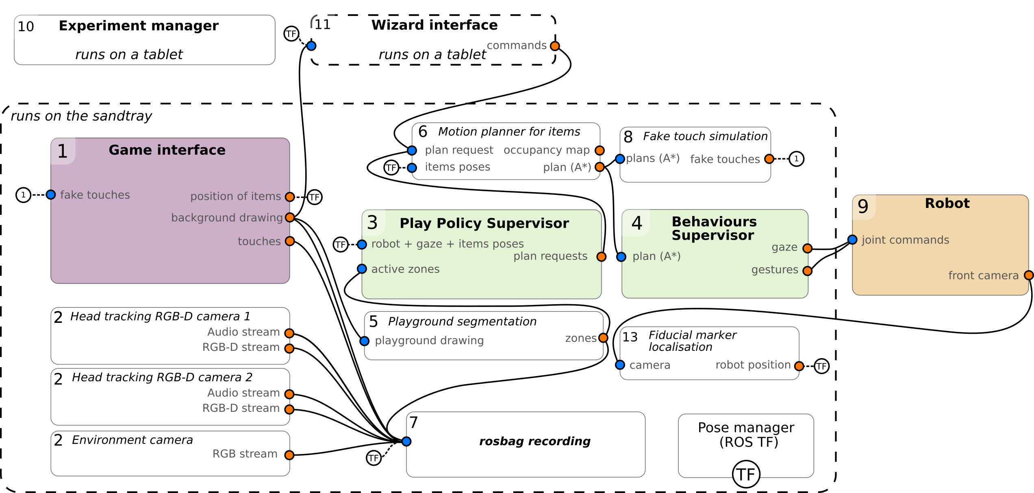

Figure 12: Software architecture of the freeplay sandbox

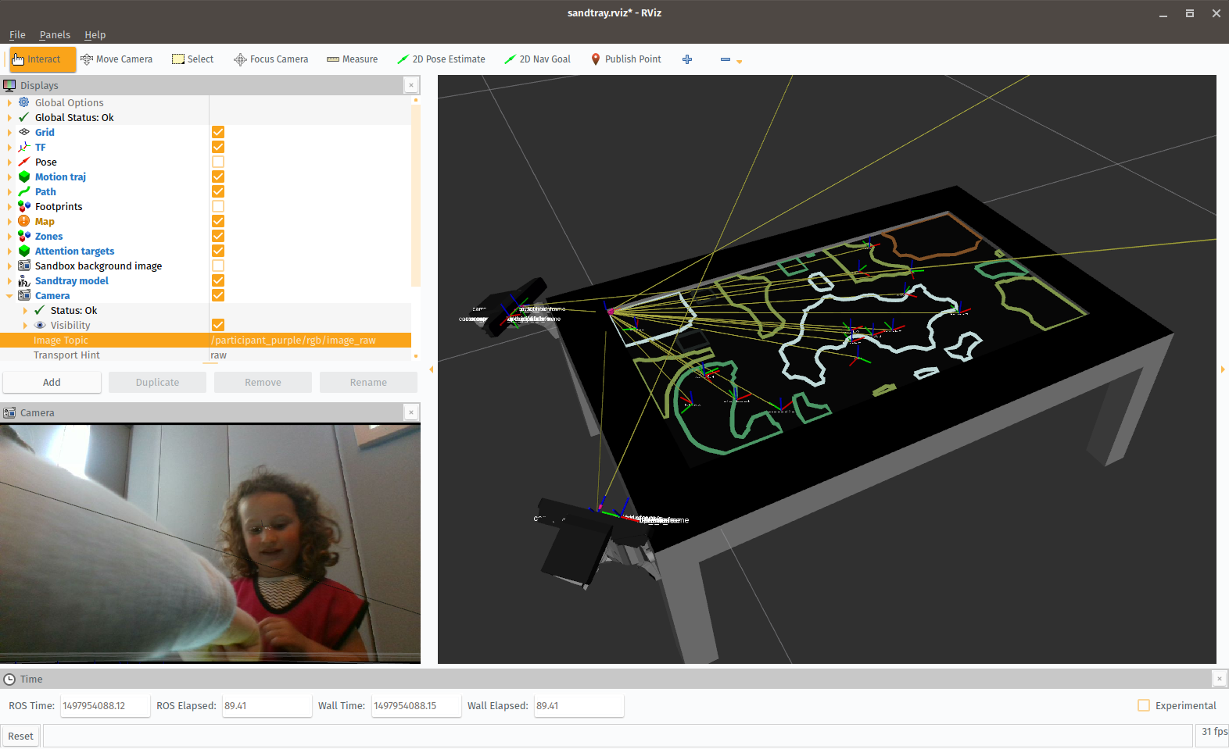

Figure 13: The free-play sandbox, viewed at runtime within ROS RViz. Simple computer vision is used to segment the background drawings into zones (visible on the right panel). The poses and bounding boxes of the interactive items are published as well, and turned into an occupancy map, used to plan the robot’s arm motion.

###### Interactive game

The interactive game (fig. 12 (1)) is coded using QML, and displays a main background image on top of which items (animals, humans and objects) can be moved. The children can also use a drawing mode to create coloured strokes on a layer between the background and the items, which adds another layer of unconstrained interaction to the game (fig. 13). The game exposes the image of the background, the drawings, and the positions of the objects as ROS TF frames.

###### Sensing

Two Intel RealSense SR300 RGB-D cameras are mounted at fixed positions on the sandtray frame, with custom designed 3D-printed brackets that ensure that the cameras are oriented towards the children’s face. Because the cameras are rigidly mounted onto the sandtray’s frame, their accurate geometric transformations with respect to the sandtray screen are known. Combined with hardware calibration, it allows for accurate localisation of the children and in particular, children’s faces. In addition to the images, both cameras can perform stereo audio recording. One ROS node per camera (fig. 12 (2)) publishes on dedicated topics the audio and video streams.

A third ‘external’ (and non-calibrated) camera is usually used as well to record the environment of the experiment with a wider angle (*environment camera* in fig. 10).

###### Robot Control

As previously stated, a robot (fig. 12 (9)) can act as play partner instead of one of the children. This robot can either be autonomous selecting actions based on the inputs provided by the sensors and the game or be controlled by a human in a Wizard of Oz fashion.

The current implementation exposes a large number of information on the game and the state of the child that can be used in the robot controller. The position of every item is exposed as a TF frame, the background is segmented in zones of identical colors (fig. 12 (5)), social element of the state the interaction are collected through the RGBD camera and the microphone facing the child. As visible on fig. 10 and fig. 15, the camera covers the head of the child as well as most of the upperbody, and applying libraries such as DLib and OpenPose, the position of facial feature and skeleton of the child are extracted and can be used to obtain: head gaze, gaze and gestures such as pointing. All these inputs can be combined to provide the robot with more social inputs to test the sociability of a robotic controller (fig. 12 (3)) and its impact on the interaction.

The robot’s location is obtained by displaying fiducial markers on the touchscreen before the start of the interaction, so the transformation between the robot coordinate system and the touchscreen is known (fig. 12 (13)). And this robot location can also be used to identify gazes from the child to the robot.

To make the children believe the robot is moving objects on the touchscreen, we synchronise a moving pointing gesture of the robot (fig. 12 (4)) and a series of fake touches (fig. 12 (8)) applied on the screen, moving the desired object. Once an object and a goal position have been selected, a planner (fig. 12 (6)) generate a path for this image using the A algorithm on an occupancy map obtained with the items footprints, then this plan is sent to a nodes synchronising the actuation on the robot and the fake touches on the game.

Other actions such as gaze, pointing or speech are also exposed as simple ROS topics.

##### Experiment Manager

The researcher has developed as well a dedicated, web-based, interface can be used by the experimenter to manage the whole experiment and data acquisition procedure (fig. 14). This interface ensures that all the required software nodes are running, allow the experimenter to check the status and, if needed, to start/stop/restart any of them. It also help managing large data collection campaigns by providing a convenient web interface (usually used by the experimenter on a tablet) to record the demographics, resetting the game interface after each session, and automatically enforcing the acquisition protocol (see tbl. 3).

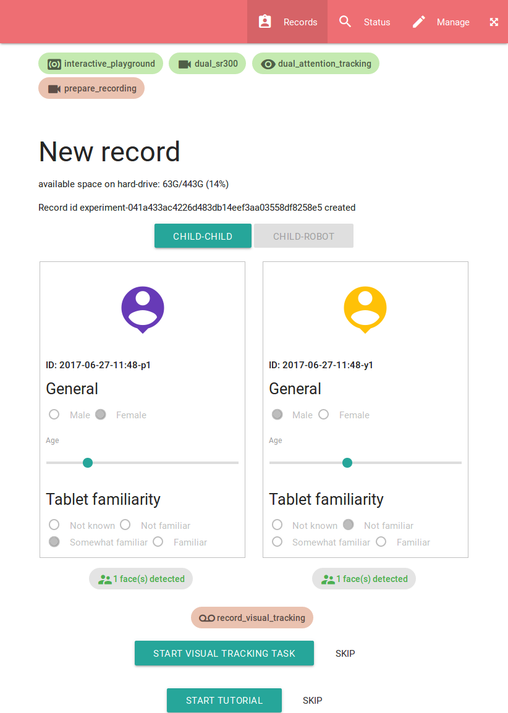

Figure 14: Experimenter interface, using web-based technologies

This interface has been extensively used to acquire the dataset that we present in the next section.

### WP3: *The PInSoRo dataset*

This work package includes the work carried out by the researcher to build a large dataset of natural human-human and human-robot social interaction, to be used for data mining and machine learning applications.

This work package replaces the original one (which was entitled *Experiment 2: Representation-level Meta-Cognition*).

In this section, we report on the work conducted by the researcher to:

1. develop new hardware and software to endow the Nao robot with depth vision and accurate gaze tracking (task T2.2);
2. develop a situation assessment tool to perform geometric reasoning and compute visual perspectives (task T2.3);
3. design and implement a novel methodology to investigate social interactions, well suited for deep-learning applications (includes task T2.2)

Additional work, including 2 experiments (D2.6 and D2.7), have been carried by the researcher. Refer to the list of additional deliverables below.

Note that task T2.1 (*adapt oro knowledge base to Nao*) and task T2.4 (*run the experiment*) are no longer relevant, following the project's refocus.

**Summary of the deliverables**

*The original deliverables D3.1 -- D3.4 are no longer applicable.*

Deliverables not present in the original project:

|  |  |
| --- | --- |
| D3.5 | New coding scheme to enable multi-dimensional analysis of social interactions |
| D3.6 | Large open-data dataset of child-child and child-robot interactions |
| D3.7 | Website to publicise and make broadly available the dataset: [freeplay-sandbox.github.io]{https://freeplay-sandbox.github.io/} |

#### Context: machine learning and social robots

The broad family of deep neural networks have repeatedly made the headlines in the last few years with reports of impressive results—notably in image classification, image labelling and automatic translation. They have been however largely ignored by other fields as they are perceived to require impossibly large datasets (hundreds of thousands to millions of observations) to actually build up useful capabilities. Even though neural networks have demonstrated compelling results in non-trivial tasks like image labelling, they did not stand out as attractive approaches to problems involving high input and output dimensions where only relatively small datasets are available – like human-robot interactions. Furthermore, if one considers “social interactions” to also entail joint behavioural dynamics, and therefore, some sort of temporal modeling, neural networks look even less enticing as time is notably absent from most of the tasks which neural networks have been successful at.

That being said, in 2015, the Google DeepMind team demonstrated how a convolutional recurrent neural network could learn to play the game Break-Out (amongst 48 other Atari games) by only looking at the gaming console screen (Mnih et al. 2015). This result represents a major milestone: they showed that a relatively small sample size (about 500 games) is sufficient for an artificial agent to not only learn how to play (which requires an implicit model of time to adequately move the Break-Out paddle), but to also create gaming strategies that look like they would necessitate planning (the system first breaks bricks on one side to eventually get the ball to break through and reach the area above the remaining bricks, therefore ensuring rapid progress in the game).

More recently, Ogata’s team (Yang et al. 2017) has demonstrated how an adequately configured RNN is able to learn a complex robotic task (folding soft objects like towels using a dual-arm mobile manipulator) from only *35* demonstrations of $≈$ 70 second-long teleoperated sequences. The network inputs are the raw video stream from the head camera and the 12 degrees of freedom of the two arms. Successfully folding towels entails an explicit sequencing of actions (therefore implicit temporal modeling). The fact that such a complex process can be successfully learned from a small training dataset should lead us to reconsider the range of domains to which RNNs would be applicable.

We believe that the complexity of mechanisms that such neural networks have been able to uncover and model should invite our community to explore its applicability to human-robot interactions (HRI) in general, and sustained, natural child-robot interactions in particular.

##### Machine Learning and Social Behaviours

The use of interaction datasets to teach robots how to socially behave has been previously explored, and can be considered as the extension of the traditional learning from demonstration (LfD) paradigms to social interactions (i.e., (Nehaniv and Dautenhahn 2007; Mohammad and Nishida 2015)). However, existing research focuses on low-level identification or generation of brief, autonomous behaviours, including social gestures (Nagai 2005) and gazing behaviours (Calinon and Billard 2006).

Based on a human-human interaction dataset, Liu et al.  (Liu et al. 2014) have investigated machine learning approaches to learn longer interaction sequences. Using unsupervised learning, they train a robot to act as a shop-keeper, generating both speech and socially acceptable motions. Their approach remains task-specific, and while they report only limited success, they emphasise the “life-likeness” of the generated behaviours. These examples show the burgeoning interest of our community for the automatic learning of social responses, but also highlight the lack of structured research efforts, as further illustrated by the limited availability of large and open datasets of social interactions, suitable for machine-learning applications.

One such dataset is the *Multimodal Dyadic Behavior Dataset* (*MMDB*, (Rehg et al. 2013)). It comprises of 160 sessions of 3 to 5 minute child-adult interactions. During these interactions, the experimenter plays with toddlers (1.5 to 2.5 years old) in a semi-structured manner. The dataset includes video streams of the faces and the room, audio, physiological data (electrodermal activity) as well as manual annotations of specific behaviours (like gaze to the examiner, laughter, pointing). While this dataset is in principle relevant, it focuses on very young children during short, adult-driven interactions. As such, it does not include episodes of naturally-occurring social interactions between peers, and the diversity of said interactions is limited. Besides, the lack of intrinsic and extrinsic camera calibration information in the dataset prevent the automatic extraction and labelling of key interaction features (like mutual gaze).

Another recent dataset, the *Tower Game Dataset* (Salter et al. 2015), focuses specifically on rich dyadic social interactions. The dataset comprises of 39 adults recorded over a total of 112 annotated sessions of 3 min in average. The participants are instructed to jointly construct a tower using wooden blocks. Interestingly, the participants are not allowed to talk to maximise the amount of non-verbal communication. The skeletons and faces of the participants are recorded, and the dataset is manually annotated with so-called *Essential Social Interaction Predicates* (ESIPs): rhythmic coupling (entrainment or attunement), mimicry (behavioral matching), movement simultaneity, kinematic turn taking patterns, joint attention. The dataset does not appear to be publicly available on-line.

The PInSoRo dataset shares the aims of the *Tower Game Dataset*, with however a stronger focus on natural, real-world behaviours: as presented in the following sections, we record much longer interactions (up to 40 minutes) of free-play interaction, capturing a wider range of socio-cognitive behaviours.

#### Baseline Datasets

We have been using the free-play sandbox task (WP2) for an initial, large scale, data collection over a period of 3 months during Spring 2017.

This campaign aimed at (1) extensively evaluating the task itself (would children engage and exhibit a large range of social dynamics and behaviours?), (2) making sure the whole software architecture and data acquisition pipeline were reliable (they were), and (3) establishing two experimental baselines for the free-play sandbox task: the ‘human’ baseline on one hand (child-child condition), an ‘asocial’ baseline on the other hand (child - *non-social* robot condition). These two baselines are situated at the two ends of the spectrum of social interaction. They aim at characterising the qualitative and quantitative bounds of this social spectrum and can be used by the research community to evaluate given interaction policies.

##### Dataset structure

The dataset consists of a collection of records. Each record correspond to one play interaction between two children. To date (June 2017) 25 records have been acquired (i.e.50 children), totalling 08h41m of recording. At the end of the acquisition campaign (July 2017), the dataset is planned to include 50 records. As the children decide themselves when to stop, the duration of each play episode varies ($M=20m51s,SD=10m40s$). It is however capped at a maximum of 40 minutes.

Data is collected using the ROS middleware[^1] and recorded as *bag* files. Tbl. 2 lists all the recorded datastreams. Every dataframe is timestamped; as the data is recorded using ROS’s bag files, it can be replayed in the exact same conditions as it has been recorded. All the video streams use calibrated cameras; only the raw RGB and depth video streams are stored in the dataset,

Table 2: List of datastreams recorded. Each datastream is timestamped with a synchronised clock to facilitate later analysis.

|  |  |  |
| --- | --- | --- |
| **Domain** | **Type** | **Details** |
| child 1 | audio | 16kHz, mono, semi-directional |
|  | face (RGB) | qHD (960 $×$ 540), 30Hz |
|  | face (depth) | VGA (640 $×$ 480), 30Hz |
|  | facial features | 68 3D points, 30Hz |
| child 2 | audio | 16kHz, mono, semi-directional |
|  | face (RGB) | qHD (960 $×$ 540), 30Hz |
|  | face (depth) | VGA (640 $×$ 480), 30Hz |
|  | facial features | 68 3D points, 30Hz |
| environment | RGB | qHD (960 $×$ 540), 29.7Hz |
| touchscreen | background drawing (RGB) | 4Hz |
|  | touches | 6 points multi-touch, 10Hz |
|  | items pos. and orient. | ($x,y,θ$), 10Hz |
| annotations |  | hand-coded video annotations |

##### Apparatus

###### Hardware

The sandtray is made of a 27" Samsung All-In-One computer running Ubuntu Linux and equipped with a fast 1TB SSD hard-drive. The computer is held horizontally in a custom aluminium frame standing 26cm above the floor (visible in fig. 10). All the cameras are plugged directly over USB-3 to the computer. The computer performs all the data acquisition using ROS Kinetic.

The children’s faces are recorded using two short range Intel RealSense SR300 RGB-D cameras (0.2m to 1.2m) placed at the corners of the sandtray (fig. 10) and tilted to face the children. The cameras are rigidly mounted on custom 3D-printed brackets. This enables a precise measurement of their 6D pose relative to the touchscreen (extrinsic calibration).

Audio is recorded from the same SR300 cameras (one audio stream is recorded for each child, from the camera facing her).

Finally, a third RGB camera (the RGB stream of a Microsoft Kinect One) records the whole interaction setting. These video stream is intended to support human coders while annotating the interaction, and is not precisely calibrated.

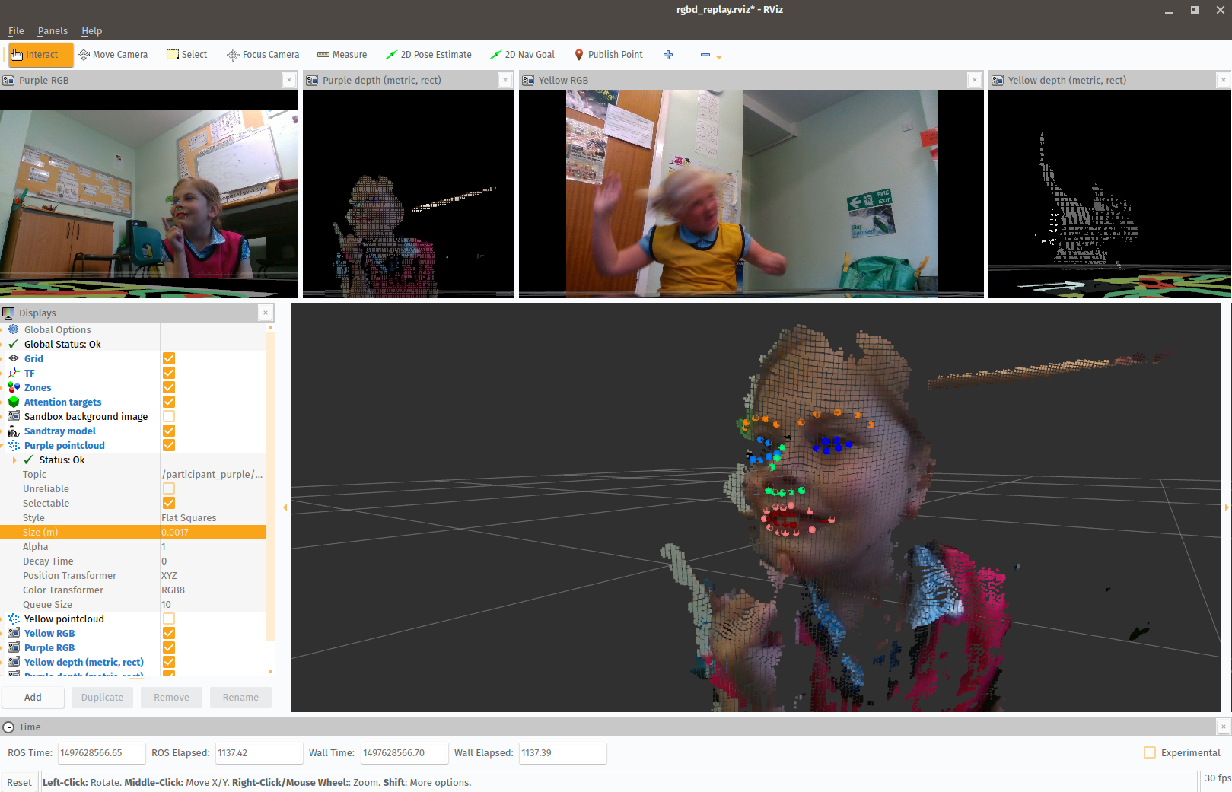

Figure 15: The reconstructed 3D point cloud of one child face with the 68 detected facial features, visualised in RViz.

###### Software

The sandbox is implemented using two software frameworks: the Qt’s QtQuick framework for the graphical interface of the game, and the *Robot Operating System* (ROS) for the modular implementation of the data processing and data acquisition pipelines. A dedicated bridge between QtQuick and ROS has been specifically developed to enable the game interface to export the positions of every interactive items as they move, the background image whenever it is painted over, and the children’s touches. The game interface is open-source and available online: <https://github.com/freeplay-sandbox/qt-gui>.

By relying on ROS for the data acquisition, real-time monitoring of the interaction is also possible (fig. 11, right). The ROS data acquisition pipeline is open-source as well, and available from <https://github.com/freeplay-sandbox/core>.

Finally, we have developed a web-based *supervisor* that enables the experimenter to remotely start/stop the ROS nodes and the game GUI, as well as to record annotations during the experiment. The supervisor ensures that the exact same recording procedure (detailed in the next section) is followed for every participants. The supervisor is available online as well: <https://github.com/freeplay-sandbox/web-supervisor>.

#### Data collection

Tbl. 2 lists the datastreams that are collected during the game. By relying on ROS for the data acquisition (and in particular the rosbag tool), we ensure all the $≈$ 10 streams are synchronised, timestamped, and, where appropriate, come with calibration information (for the cameras mainly). In our experiments, cameras were configured to stream in qHD resolution (960$$540 pixels) in an attempt to balance high enough resolution with tractable file size. It results in *bag* files weighting $≈$ 1GB per minute.

In our own experiments, all the data (including up to 5 simultaneous video streams) was recorded on a single computer (quad core i7-3770T, 8GB RAM) equipped with a fast 4TB SSD drive. This computer was also running the game interface on its touch-enabled screen (sandtray), making the whole system compact and easy to deploy (one single device).

##### Demographics

In total, 120 children were recorded for a total duration of 45 hours and 48 minutes of data collection. These 120 children (age 4 to 8) were recorded at their local school, or at the Plymouth University BabyLab (as suggested in the DoRoThy project).

The children were split into two conditions: a child-child condition and a child-robot condition. In both condition, and after a short tutorial, the children were simply invited to freely play with the sandbox, for as long as they wished (with a cap at 40 min).

In the child-child condition (as seen in fig. 18), 45 free-play interactions (i.e., 90 children) were recorded with a duration M=24.15 min (SD=11.25 min).

In the child-robot condition, 30 children were recorded, M=19.18 min (SD=10 min). In this later condition, the robot behaviour was coded to be purposefully *asocial*: the robot would autonomously play with the game items, but would avoid any social interaction (no social gaze, no verbal interaction, no reaction to the child-initiated game actions).

Over the dataset, the children faces are detected on 98% of the images, which validates the location of the camera and the children to use the cameras to obtain facial social features.

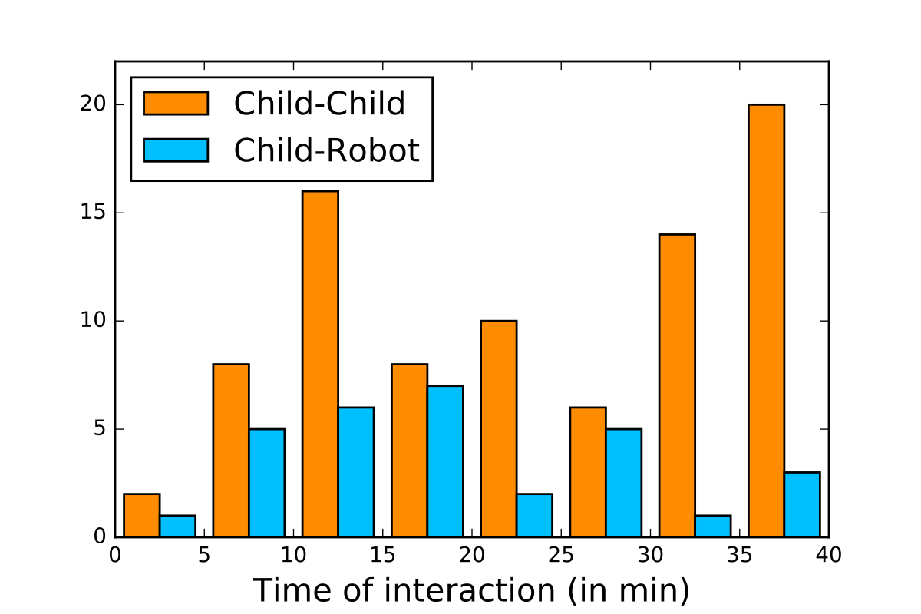

Figure 16: Durations of the interactions for the two conditions.

Fig. 16 presents an histogram of the durations of the interactions for the two baselines. The distribution of the child-child interaction durations shows that (1) all children engage easily and for non-trivial amounts of time with the task; (2) the task leads to a wide range of level of commitment, which is desirable: it supports the claim that the free-play sandbox is an effective paradigm to observe a range of different social behaviours; (3) long interactions (>30 min) can result, which is especially desirable to study social dynamics.

In contrast, and notwithstanding the smaller number of participants, the distribution of the child-robot interaction durations shows these interactions are generally shorter. This is expected as the robot was explicitly programmed not to interact with the children, resulting in a rather boring (and at time, awkward) situation where the child and the robot where playing side-by-side – in some case for rather long periods of time – without interacting at all.

##### Protocol

We typically adhere to the acquisition procedure described in tbl. 3 with all participants. To ease later identification, each child is also given a different and brightly coloured sports bib to wear.

Importantly, during the *Greetings* stage, we show the robot both moving and speaking (for instance, “Hello, I’m Nao. Today I’ll be playing with you. Exciting!” while waving at the children). This is meant to set the children’s expectations: they have seen that the robot can speak, move, and even behave in a social way.

Also, the game interface of the free-play sandbox offers a tutorial mode, used to ensure the children know how to manipulate items on a touchscreen and draw. In our experience, this has never been an issue for children.

Table 3: Data acquisition protocol

|  |
| --- |
| **Greetings** *(about 5 min)* |
| explain the purpose of the study: showing robots how children play |
| briefly present a Nao robot: the robot stands up, gives a short message, and sits down. |
| place children on cushions |
| complete demographics on the tablet |
| remind the children that they can withdraw at anytime |
| **Tutorial** *(1-2 min)* |
| explain how to interact with the game, ensure the children are confident with the manipulation/drawing |
| **Free-play task** (up to 40 min) |
| initial prompt: *“Just to remind you, you can use the animals or draw. Whatever you like. If you run out of ideas, there’s also an ideas box. For example, the first one is a zoo. You could draw a zoo or tell a story. When you get bored or don’t want to play anymore, just let me know.”* |
| let children play |
| once they wish to stop, stop recording |
| **Debriefing** *(about 2 min)* |
| answer possible questions from the children |
| give small reward (e.g.,stickers) as a thank you |

#### Data processing

##### Face and body pose analysis

Off-line post-processing has been performed on the images obtained from the cameras. We rely on the CMU OpenPose library (Cao et al. 2017) to extract for both children the upper-body skeleton, 70 facial landmarks including the pupil position, as well as the hands’ skeleton (when visible).

##### Game interactions analysis

Game features are also produced by the different nodes involved in the analysis of the game. The Playground segmentation produce a map of the regions based on the colour which can be used with the positions of the animal to identify from which zone to which zone an animal has been moved. The relative position of animal can also indicate if two animals have been moved closer. These relations and the drawing inform on what high level action the child is doing and can be used to infer the child’s goal or desire.

#### Annotation of Social interactions

Annotating social interaction beyond surface behaviours is generally difficult. The observable, surface behaviours typically result of a superposition of the complex and non-observable underlying cognitive and emotional states. As such, these deeper socio-cognitive states can only be indirectly observed, and their labelling is typically error prone.

Our aim is to provide insights on the social dynamics, and we have synthesised a new coding scheme for social interactions that reuse and adapt established social scales. Our coding scheme (fig. 17) looks specifically at three axis: the level of *task engagement* (that distinguishes between *focused*, *task oriented* behaviours, and *disengaged* – yet sometimes highly social – behaviours); the level of social engagement (reusing Parten’s stages of play, but at the micro-task level); the social attitude (that encode attitudes like *supportive*, *aggressive*, *dominant*, *annoyed*, etc.)

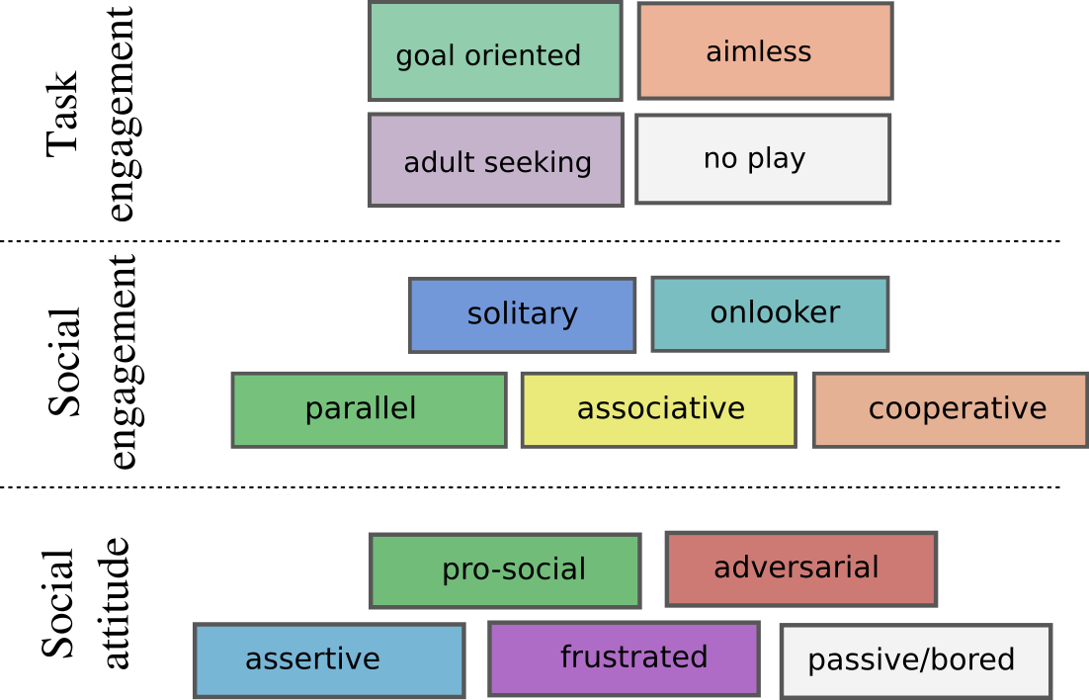

Figure 17: The coding scheme used for annotating social interactions occurring during free-play episodes. Three main axis are studied: task engagement, social engagement and social attitude.

###### Task engagement

The first axis of our coding scheme aims at making a broad distinction between ‘on-task’ behaviours (even tough the free-play sandbox does not explicitly require the children to perform a specific task, they are still engaged in an underlying task: to play with the game) and ‘off-task’ behaviours. We call ‘on-task’ behaviours *goal oriented*: they encompass considered, planned actions (that might be social or not). *Aimless* behaviours (with respect to the task) encompass opposite behaviours: being silly, chatting about unrelated matters, having a good laugh, etc. These *Aimless* behaviours are in fact often highly social, and play an important role in establishing trust and cooperation between the peers. In that sense, they should not be discarded.

###### Social engagement: Parten’s stages of play at micro-level

In our scheme, we characterise *Social engagement* by building upon Parten’s stages of play. These 5 stages of play are normally used to characterise rather long sequences (at least several minutes) of social interactions. Here, we apply them at the level of each of the micro-sequences of the interactions: one child is drawing and the other is observing is labelled as *solitary play* for the former child, *on-looker* behaviour for the later; the two children discuss what to do next: this sequence is annotated as a *cooperative* behaviour; etc.

By suggesting such a fine-grained coding of social engagement, we enable proper analyses of the internal dynamics of a long sequence of social interaction.

###### Social attitude

The constructs related to the social *attitude* of the children derive from the *Social Communication Coding System* (SCCS) proposed by Olswang et al. (Olswang et al. 2006). The SCCS consists in 6 mutually exclusive constructs characterising social communication (*hostile*; *pro-social*; *assertive*; *passive*; *adult seeking*; *irrelevant*) and were specifically created to characterise children communication in a classroom setting.

We transpose these constructs from the communication domain to the general behavioural domain, keeping the *pro-social*, *hostile* (whose scope we broaden in *adversarial*), *assertive* (i.e., dominant), and *passive* constructs. In our scheme, the *adult seeking* and *irrelevant* constructs belong to Task Engagement axis.

Finally, we have added the construct *Frustrated* to describe children who are reluctant or refuse to engage in a specific phase of interaction because of a perceived lack of fairness or attention from their peer, or because they fail at achieving a particular task (like a drawing).

###### Video coding

The coding bas been performed post-hoc with the help of a dedicated annotation tool created by the researcher (fig. 18) which is part of the free-play sandbox toolbox. This tool can replay and randomly seek in the three video streams, synchronised with the recorded state of the game (including the drawings as they are created). An interactive timeline displaying the annotations is also displayed.

The annotation tool offers a remote interface for the annotator (made of large buttons, and visually similar to fig. 17) that is typically displayed on a tablet and allow the simultaneous coding of the behaviours of the two children. Usual video coding practices (double-coding of a portion of the dataset and calculation of an inter-judge agreement score) would have to be followed.

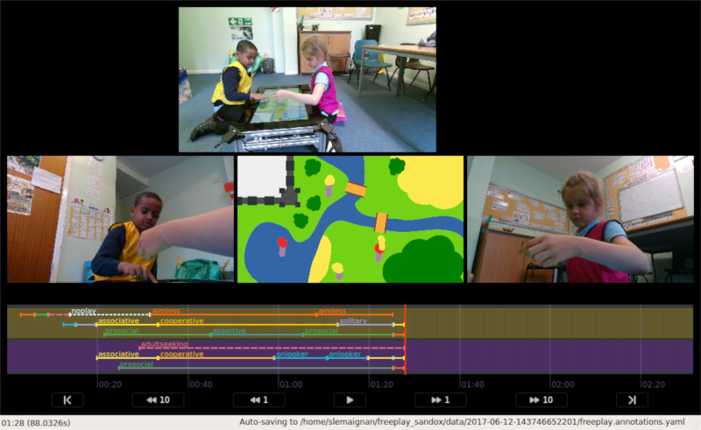

Figure 18: Screenshot of the dedicated tool developed for rapid annotation of the social interactions.

##### Ethical considerations and dataset availability

All data has been collected by the researcher, with the help of a research assistant (paid by the DoRoThy project as well).

The presented experimental protocol had been approved by the university ethics committee. The parents of the participants explicitly consented to sharing of their child’s video and audio with the research community. The data is labelled with a unique participant code only and does not contain any identifying information, except the participant’s images. The child’s age and gender are also available.

Following the EU H2020 open-data approach, **the dataset is freely available to any interested researcher, and can be requested online: [freeplay-sandbox.github.io]{https://freeplay-sandbox.github.io/}**. Due to ethical and data protection regulations, the dataset is however made available in two forms: a public, Creative Commons licensed, version that does not include any video material of the children (no video streams, audio included); and a complete version that includes all video streams. This second version is freely available as well, but interested researchers must first fill a data protection form.

### WP4: *Management, dissemination and knowledge transfer*

The main tasks conducted in the WP4 include:

* preparation of academic publications
* participation to conferences, including invited talks/keynotes
* organisation of conferences and workshops
* student supervision and teaching
* participation to interdisciplinary seminars
* robotic workshops organised with local schools
* participation to public event to promote and present academic research in robotics
* providing online visibility to the researcher's academic activities

**Summary of the deliverables**

|  |  |
| --- | --- |
| D4.1 Media press release for the European Robotic Week | [UK robotic week 2016](https://www.plymouth.ac.uk/whats-on/uk-robotics-week-at-plymouth-university), [UK robotic week 2017](https://www.plymouth.ac.uk/whats-on/uk-robotics-week-2017), awarded Best Presentation Award at Plymouth's UK Robotic Week 2017 |
| D4.2 Proceedings from workshop on meta-cognition | Superseded by [proceedings of the Workshop on Cognitive Architectures](https://sites.google.com/site/cogarch4socialhri2016/proceedings) |
| D4.3 Scientific publications | 12 publications + 4 under review, see list |
| D4.4 Press release of the MSC Project Open Day | Did not take place |
| D4.5 Press release of the museum exhibition | Did not take place |
| D4.6 2-weeks research stay at Aldebaran robotics | Canceled due to staff changes at Aldebaran Robotics |

Additional deliverables, not present in the original project: *see below*

#### Academic publications

Over the course of the DoRoThy project, the researcher has authored or co-authored **12 peer-reviewed publications**, all acknowledging the EU H2020 funding of the DoRoThy project.

The complete list of publications is provided in the appendices.

One additional publication could not acknowledge the DoRoThy grant (as it was published before the grant agreement was signed), but it is mentioned here as it result directly from the research conducted to prepare the DoRoThy grant.

#### Conferences & Invited talks

Over the course of the DoRoThy project, the research was invited to present his research to the following conferences:

* 03/2016: **HRI 2016** (2 talks)
* 03/2017: **HRI 2017** (1 talk)
* 11/2017: **AAAI Fall Symposium** - AI for HRI (**invited keynote**)

In total, about 1000 academics have been reached during these 3 events.

Besides, the researcher gave **8 seminars or invited talks** in other institutions (**both UK and international** ones), with **3 more to take place** in the coming 3 months:

* 11/2015: HRI2016 (invited talk - HRI mini symposium at Standford University, USA)
* 09/2016: Bristol Robotics Lab (seminar, UK)
* 11/2016: HRI2017 (invited talk - HRI mini symposium at Wien University, Austria)
* 01/2017: INRIA Bordeaux (seminar, France)
* 02/2017: Heriot Watt (seminar, UK)
* 02/2017: Edimburgh University (seminar, UK)
* 05/2017: Heriot Watt (invited talk, UK)
* 04/2017: IST Lisbon (seminar, Portugal)

Planned:

* 11/2017: HRI2018 (invited talk - HRI mini symposium at Cornell University, USA)
* 01/2018: LAAS CNRS (seminar - France)
* 01/2018: IIT Genoa (seminar - Italy)

### Participation to interdisciplinary seminars

In addition to the seminars and invited talks already mentioned above, the researcher has also been invited to take part to seminars organised in neighbouring fields:

* 02/2017: invited talk at the CogNovo interdisciplinary symposium on Creativity, Plymouth University
* 11/2017: invited to give a seminar at the School of Psychology, Plymouth University

#### Organisation of conferences and workshops

In 2015, the researcher was tasked with the organisation of the **workshop on attention tracking** during the [HRI Summer School 2015](https://hrisummerschool15.wordpress.com/). The teaching material created for the occasion is openly available online on the researcher's GitHub account: [github.com/severin-lemaignan/attention-assessment-workshop](https://github.com/severin-lemaignan/attention-assessment-workshop).

From 2016 onwards, the researcher hold an (invite-only) editorial role as **Program Committee member** for the HRI conference in 2016, 2017 and 2018, and the IROS conference 2016 and 2017.

As a member of the Program Committee of the HRI conference, the researcher has been invited and attended 3 3-days long PC meetings in 2015, 2016 and 2017, where he was working in close proximity with the leading academics in the Human-Robot Interaction field. These meetings have been **invaluable opportunities for the researcher to develop interpersonal relations and build a strong international network with his peers**.

In 2016, the researcher also **organised a successful workshop** (with about 30 participants) **on Cognitive Architecture for Social Robotics** (with P. Baxter and G. Trafton) (Baxter, Lemaignan, and Trafton 2016). The website of the workshop, as well as the proceedings, can be found here: [Workshop on Cognitive Architectures](https://sites.google.com/site/cogarch4socialhri2016/proceedings).

In 2017, the researcher was invited to **organise and chair the recently created *alt.HRI* track of the HRI conference**, gathering radical and possibly provocative, yet high quality, research in the field of Human-Robot Interaction.

#### Student supervision and teaching

From 2015 to 2017, the researcher has **co-supervised 2 PhD students** (Emmanuel Senft and Chris Wallbridge).

This supervision activity has led to several co-authored publications with these students:

* **Supervised Autonomy for Online Learning in Human-Robot Interaction** (Senft, Baxter, et al. 2017)
* **Qualitative Review of Object Recognition Techniques for Tabletop Manipulation** (Wallbridge, Lemaignan, and Belpaeme 2017)
* **Toward Supervised Reinforcement Learning with Partial States for Social HRI** (Senft, Lemaignan, et al. 2017b)
* **Leveraging Human Inputs in Interactive Machine Learning for Human Robot Interaction** (Senft, Lemaignan, et al. 2017a)
* **SPARC: an efficient way to combine reinforcement learning and supervised autonomy** (Senft, Lemaignan, et al. 2016)
* **Providing a Robot with Learning Abilities Improves its Perception by Users** (Senft, Baxter, et al. 2016)

Publications under review:

* **The Free-play Sandbox: a Novel Methodology for the Evaluation of Social Robotics**
  + S. Lemaignan; E. Senft; T. Belpaeme
* **Spatial Referring Expressions: Establishing Common Ground in Child-Robot Interaction**
  + C. Wallbridge; S. Lemaignan; T. Belpaeme

Besides, the researcher **engaged with teaching activities** during one semester (Autumn 2016), taking over 2 hours/week of lectures and 3 hours/week of lab. The module (ROCO318: Mobile and Humanoid Robots) aimed at 3rd year students. The teaching material is open and available online: [github.com/severin-lemaignan/module-mobile-and-humanoid-robots](https://github.com/severin-lemaignan/module-mobile-and-humanoid-robots).

This initial teaching experience has proven instrumental in getting a permanent lecturer position at the host institution at the end of the project.

### Public Engagement

The researcher has engaged several times in public dissemination, with both adults and children.

First, the researcher conducted in different occasions a total 4 demonstrations and Q&A sessions in 2 schools and one nursery (reaching about **75 children**).

Second, the researcher co-organised and took part to two editions of the UK Robotic Week ([UK robotic week 2016](https://www.plymouth.ac.uk/whats-on/uk-robotics-week-at-plymouth-university), [UK robotic week 2017](https://www.plymouth.ac.uk/whats-on/uk-robotics-week-2017)). In particular, a public open day was organised at each of these events, comprising of public demonstration of robots and a short scientific presentation to a wide audience. About **100 persons** were reached during these events, and the researcher was awarded the **Best Presentation Award** for his presentation during the UK Robotic Week 2017.

### Providing online visibility to the researcher's academic activities

Finally, the researcher's academic website, [academia.skadge.org](https://academia.skadge.org/) has been regularly updated over the course of the project, referencing both recent news like conferences and talks, as well as background information on the researcher's research and a complete list of publications.

## 1.3 Impact

### 1.3.1 Scientific impact

The central foreseen impact of DoRoThy was to promote and further develop the *European leadership in cognitive robotics as well as natural human-robot interaction* (Section 3.1 of Annex 1). While the detailed work carried out over the course of the project has significantly deviated from the original proposed plan (as presented in Section 1.1.1 and Section 5 below), DoRoThy has achieved this high-level goal, by effectively laying the ground for a novel research paradigm for cognitive robotics and human-robot interaction: deep-learning of social interaction.

The two main contribution of the DoRoThy project are the 'free play sandbox' experimental methodology and the new PInSoRo dataset of social interactions.

The free play sandbox paradigm is expected to play an important role for the future development of social robotics, as it offers one possible solution to the critical issue of the experimental validation of social robotics research: by offering an experimental platform eliciting natural social behaviours, relatively unconstrainted, essentially non-deterministic, yet sufficiently well defined to be measurable and easily reproducible, we have created an important tool to scaffold future research in social HRI.

The PInSoRo dataset of social interaction, created during the project, is expected to have a major impact on the way we study human-robot interaction, and more broadly, human-human interactions. For the first time, we make available to the broad academic community a dataset of social interactions rigorous enough and large enough to enable machine learning and data-mining at the behavioural level.

By releasing the dataset under an open-data license, we hope to reach a large audience, in the social robotics community, and beyond, in the broader social psychology academic community. By the end of the project, the lead DoRoThy researcher has been already invited to give seminars and talks in about 10 institutions worldwide, including a keynote during the 2017 edition of the prestigious Fall Symposium of the Association for the Advance of Artificial Intelligence, where the PInSoRo dataset will be officially presented. Details and access to the dataset are available on the project website, [freeplay-sandbox.github.io/](https://freeplay-sandbox.github.io/).

These two contributions, alongside the other supervision and dissemination activities conducted by the researcher (see WP4), have led to significant progress towards the understanding and analysis of complex, natural social interactions.

### 1.3.2 Impact on the researcher career

During the DoRoThy project, the researcher has attended three workshop, intended to develop his technical knowledge and leadership skills:

* a 3 days technical workshop on CUDA and Deep Neural Network, organised at Plymouth University by a NVidia expert;
* a one day course on PhD supervision, organised by the host institution;
* a one day course on research funding, organised by the host institution.

Besides, over the course of the DoRoThy project, the researcher significantly developed his academic track record: **12 new publications**, numerous seminars and invited talks, including **one keynote in an international symposium**, the organisation of a workshop on cognitive architecture (with P. Baxter and G. Trafton) during the high profile HRI conference, editorial role as **Program Committee member** of the HRI conference in 2016, 2017 and 2018, and the IROS conference 2016 and 2017, organiser and chair of the alt.HRI track for the HRI2017 conference.

The researcher gave **8 seminars or invited talks** in other institutions (**both UK and international** ones), with **4 more to take place** in the coming 3 months (see description of WP4).

This academic excellence has been recognised within the Social Robotics academic community: **Best Design Paper award** at the HRI2017 conference; **Best Presentation award** at the Plymouth University UK Robotics Week symposium; invitations for seminars and keynotes; and more significantly, career perspectives: at the end of the DoRoThy project, the research has been **offered two permanent academic positions**, one as **lecturer in robotics and AI at Plymouth University**, one as **Senior Research Fellow at Bristol Robotics Lab**.

**As such, 6 months after the end of the Marie Curie action DoRoThy, the research is to be established in a senior academic role in one of the top European research lab in robotics.**

# 2. Update of the plan for exploitation and dissemination of result

N/A

# 3. Update of the data management plan

N/A

# 4. Follow-up of recommendations and comments from previous review(s)

N/A

# 5. Deviations from Annex 1 and Annex 2

## 5.1 Tasks

As presented in section 1.1.1, the DoRoThy project underwent a significant shift of focus after an initial period of 6 to 8 months of initial investigation (see report on WP1 and WP2).

In order to maximise the impact potential of the project, the project essentially shifted from *symbolic cognition for theory of mind* to *social interactions and machine learning*.

To better reflect this change, the titles of the first 3 work packages have been modified, as indicated in section 1.1.1:

* Work Package 1: *Formal Model of Representation-level Meta-Cognition for Robots* becomes *Models of social cognition for human-robot interaction*;
* Work package 2: *Experiment 1: Standard False-Belief Experiment* becomes *Experimental Frameworks for the Study of Social HRI*;
* Work package 3: *Experiment 2: Representation-level Meta-Cognition* becomes *The PInSoRo dataset of Social HRI*;

# 6. Appendices

## 6.1 List of publications by the researcher

List of academic publications where the DoRoThy grant is acknowledged.

### International peer-reviewed journals

* **Supervised Autonomy for Online Learning in Human-Robot Interaction** (Senft, Baxter, et al. 2017)
* **Artificial Cognition for Social Human-Robot Interaction: An Implementation** (S. Lemaignan, Warnier, et al. 2016)

### International peer-reviewed conference articles (6-8 pages)

* **Qualitative Review of Object Recognition Techniques for Tabletop Manipulation** (Wallbridge, Lemaignan, and Belpaeme 2017)
* **Toward Supervised Reinforcement Learning with Partial States for Social HRI** (Senft, Lemaignan, et al. 2017b)
* **Cellulo: Versatile Handheld Robots for Education** (Özgür et al. 2017)
* **Child Speech Recognition in Human-Robot Interaction: Evaluations and Recommendations** (Kennedy et al. 2017)
* **From Characterising Three Years of HRI to Methodology and Reporting Recommendations** (Baxter et al. 2016)

### Short peer-reviewed publications

* **Leveraging Human Inputs in Interactive Machine Learning for Human Robot Interaction** (Senft, Lemaignan, et al. 2017a)
* **SPARC: an efficient way to combine reinforcement learning and supervised autonomy** (Senft, Lemaignan, et al. 2016)
* **Towards Machine-Learnable Child-Robot Interactions: the PInSoRo Dataset** (S. Lemaignan, Kennedy, et al. 2016)
* **The Cautious Attitude of Teachers Towards Social Robots in Schools** (Kennedy, Lemaignan, and Belpaeme 2016)
* **Providing a Robot with Learning Abilities Improves its Perception by Users** (Senft, Baxter, et al. 2016)
* **Workshop on Cognitive Architectures for Social Human-Robot Interaction** (Baxter, Lemaignan, and Trafton 2016)

### Publications under review:

* **underworlds: Cascading Situation Assessment for Robots**
  + S. Lemaignan; F. Papadopoulos; T. Belpaeme
  + HRI 2018
* **The Free-play Sandbox: a Novel Methodology for the Evaluation of Social Robotics**
  + S. Lemaignan; E. Senft; T. Belpaeme
  + HRI 2018
* **Spatial Referring Expressions: Establishing Common Ground in Child-Robot Interaction**
  + C. Wallbridge; S. Lemaignan; T. Belpaeme
  + HRI 2018
* **Social psychology and HRI: an uneasy marriage**
  + B. Irfan; J. Kennedy; S. Lemaignan; F. Papadopoulos; E. Senft; T. Belpaeme
  + alt HRI 2018

### Other publication related to the project

* **Mutual Modelling in Robotics: Inspirations for the Next Steps** (Lemaignan and Dillenbourg 2015)

## 6.2 Open-source code contributions

### 6.2.1 New projects or projects with major new contributions resulting from the DoRoThy project

*The DoRoThy principal investigator is the main (or unique) developer of these softwares.*

* **gazr**
  + a tool to estimate 6D head pose and gaze from facial features
  + [*https://github.com/severin-lemaignan/gazr*](https://github.com/severin-lemaignan/gazr)
* **underworlds**
  + 3D ‘cascading’ and distributed situation assessment framework
  + [*https://github.com/severin-lemaignan/underworlds*](https://github.com/severin-lemaignan/underworlds)
* **boxology**
  + GUI to design large software architectures
  + [*https://github.com/severin-lemaignan/boxology*](https://github.com/severin-lemaignan/boxology)
* **associative-memory**
  + a fast implementation of the Associative Memory artificial network proposed by P. Baxter (Baxter et al. 2012)
  + [*https://github.com/severin-lemaignan/associative-memory*](https://github.com/severin-lemaignan/associative-memory)
* **ros-qml**
  + an extensive bridge allowing seamless interfacing between ROS and Qt QML.
  + [*https://github.com/severin-lemaignan/ros-qml-plugin*](https://github.com/severin-lemaignan/ros-qml-plugin)
* **freeplay-sandbox**
  + a ‘sandbox’ environment for the investigation of face-to-face social interactions
  + **core**
    - ROS-based interaction and robot controllers
    - [*https://github.com/freeplay-sandbox/core*](https://github.com/freeplay-sandbox/core)
  + **qt-gui**
    - User interface, for multitouch tangible tables
    - [*https://github.com/freeplay-sandbox/qt-gui*](https://github.com/freeplay-sandbox/qt-gui)
  + **analysis**
    - Dataset analysis toolkit, including gaze analysis and skeleton extraction
    - [*https://github.com/freeplay-sandbox/analysis*](https://github.com/freeplay-sandbox/analysis)
  + **annotator**
    - Highly efficient, multi-modal video annotation tool
    - [*https://github.com/freeplay-sandbox/annotator*](https://github.com/freeplay-sandbox/annotator)
* **oro**
  + the OpenRobots Ontology
  + minimalkb ontology server: [*https://github.com/severin-lemaignan/minimalkb*](https://github.com/severin-lemaignan/minimalkb)
  + liboro bindings: [*https://github.com/severin-lemaignan/liboro*](https://github.com/severin-lemaignan/liboro)
  + dialogs natural language processing: [*https://github.com/severin-lemaignan/dialogs*](https://github.com/severin-lemaignan/dialogs)
  + oro-view OpenGL ontology viewer: [*https://github.com/severin-lemaignan/oro-view*](https://github.com/severin-lemaignan/oro-view)
* **openni-python**
  + Python bindings for the OpenNI depth processing framework
  + [*https://github.com/severin-lemaignan/openni-python*](https://github.com/severin-lemaignan/openni-python)

### 6.2.2 Other open-source projects with new contributions resulting from the DoRoThy project

* **morse**
  + a versatile simulator for robotics, with support for human-robot interactions
  + [*https://github.com/morse-simulator/morse*](https://github.com/morse-simulator/morse)
* **dlib**
  + large library of machine-learning routines
  + [*https://github.com/davisking/dlib*](https://github.com/davisking/dlib)
* **naoqi_libqi / naoqi_libqicore**
  + ROS support for Aldebaran’s Nao and Pepper robots
  + [*https://github.com/ros-naoqi/*](https://github.com/ros-naoqi/)
* **ros-realsense**
  + Intel-supported ROS bridge for the Realsense RGB-D cameras
  + [*https://github.com/intel-ros/realsense*](https://github.com/intel-ros/realsense)
* **pyassimp**
  + Python bindings for the Assimp 3D assets loading library
  + [*https://github.com/assimp/assimp/*](https://github.com/assimp/assimp/)

## 6.3 References

Baader, Franz, Diego Calvanese, Deborah L. McGuinness, Daniele Nardi, and Peter F. Patel-Schneider, eds. 2003. *The Description Logic Handbook: Theory, Implementation and Applications*. 2nd ed. New York, NY, USA: Cambridge University Press.

Baron-Cohen, S., A.M. Leslie, and U. Frith. 1985. “Does the Autistic Child Have a ‘Theory of Mind’ ?” *Cognition*.

Baron-Cohen, Simon. 1989. “Perceptual Role Taking and Protodeclarative Pointing in Autism.” *British Journal of Developmental Psychology* 7 (2). Wiley Online Library: 113–27.

———. 1992. “Out of Sight or Out of Mind? Another Look at Deception in Autism.” *Journal of Child Psychology and Psychiatry* 33 (7). Wiley Online Library: 1141–55.

Baron-Cohen, Simon, Alan M Leslie, and Uta Frith. 1986. “Mechanical, Behavioural and Intentional Understanding of Picture Stories in Autistic Children.” *British Journal of Developmental Psychology* 4 (2). Wiley Online Library: 113–25.

Baron-Cohen, Simon, Amy Spitz, and Pippa Cross. 1993. “Do Children with Autism Recognise Surprise? A Research Note.” *Cognition & Emotion* 7 (6). Taylor & Francis: 507–16.

Baxter, P., J. Kennedy, Senft E., S. Lemaignan, and T. Belpaeme. 2016. “From Characterising Three Years of Hri to Methodology and Reporting Recommendations.” In *Proceedings of the 2016 Acm/Ieee Human-Robot Interaction Conference (Alt.HRI)*. doi:[10.1109/HRI.2016.7451777](https://doi.org/10.1109/HRI.2016.7451777).

Baxter, P., S. Lemaignan, and G. Trafton. 2016. “Workshop on Cognitive Architectures for Social Human-Robot Interaction.” In *Proceedings of the 2016 Acm/Ieee Human-Robot Interaction Conference*. doi:[10.1109/HRI.2016.7451865](https://doi.org/10.1109/HRI.2016.7451865).

Baxter, Paul, Joachim De Greeff, Rachel Wood, and Tony Belpaeme. 2012. “Modelling Concept Prototype Competencies Using a Developmental Memory Model.” *Paladyn, Journal of Behavioral Robotics* 3 (4): 200–208.

Baxter, Paul, Rachel Wood, and Tony Belpaeme. 2012. “A Touchscreen-Based ‘Sandtray’to Facilitate, Mediate and Contextualise Human-Robot Social Interaction.” In *Human-Robot Interaction (Hri), 2012 7th Acm/Ieee International Conference on*, 105–6. IEEE.

Block, Ned. 1996. “How Can We Find the Neural Correlate of Consciousness?” *Trends in Neurosciences* 19 (11). Elsevier: 456–59.

Calinon, Sylvain, and Aude Billard. 2006. “Teaching a Humanoid Robot to Recognize and Reproduce Social Cues.” In *Proc. of the 15th Ieee Int. Symp. on Robot and Human Interactive Communication*, 346–51. IEEE.

Cao, Zhe, Tomas Simon, Shih-En Wei, and Yaser Sheikh. 2017. “Realtime Multi-Person 2D Pose Estimation Using Part Affinity Fields.” In *CVPR*.

Clark, Herbert H, and Susan E Brennan. 1991. “Grounding in Communication.” *Perspectives on Socially Shared Cognition* 13 (1991): 127–49.

Clark, Herbert H, and Deanna Wilkes-Gibbs. 1986. “Referring as a Collaborative Process.” *Cognition* 22 (1). Elsevier: 1–39.

Desimone, Robert, and John Duncan. 1995. “Neural Mechanisms of Selective Visual Attention.” *Annual Review of Neuroscience* 18 (1). Annual Reviews 4139 El Camino Way, PO Box 10139, Palo Alto, CA 94303-0139, USA: 193–222.

Ditmarsch, Hans P van. 2002. “The Description of Game Actions in Cluedo.” *Game Theory and Applications* 8. Nova Science Publishers: 1–28.

Ditmarsch, Hans van, and Willem Labuschagne. 2007. “My Beliefs About Your Beliefs: A Case Study in Theory of Mind and Epistemic Logic.” *Synthese* 155 (2). Springer: 191–209.

Ditmarsch, Hans van, Andreas Herzig, and Tiago De Lima. 2010. “From Situation Calculus to Dynamic Epistemic Logic.” *Journal of Logic and Computation*. Oxford Univ Press.

Ditmarsch, Hans van, Wiebe van der Hoek, and Barteld Pieter Kooi. 2007. *Dynamic Epistemic Logic*. Vol. 337. Springer.

Fagin, Ronald, Joseph Y. Halpern, Yoram Moses, and Moshe Y. Vardi. 1995. *Reasoning About Knowledge*. Cambridge, MA, USA: MIT Press.

Flavell, John H, Frances L Green, and Eleanor R Flavell. 1990. “Developmental Changes in Young Children’s Knowledge About the Mind.” *Cognitive Development* 5 (1). Elsevier: 1–27.

Flobbe, Liesbeth, Rineke Verbrugge, Petra Hendriks, and Irene Krämer. 2008. “Children’s Application of Theory of Mind in Reasoning and Language.” *Journal of Logic, Language and Information* 17 (4). Springer: 417–42.

Frith, Uta, and Francesca Happé. 1994. “Autism: Beyond ‘Theory of Mind’.” *Cognition* 50 (1). Elsevier: 115–32.

Graziano, Michael SA. 2013. *Consciousness and the Social Brain*. Oxford University Press.

Happé, Francesca GE. 1993. “Communicative Competence and Theory of Mind in Autism: A Test of Relevance Theory.” *Cognition* 48 (2). Elsevier: 101–19.

Hendricks, Vincent, and John Symons. 2008. “Epistemic Logic.” In *Stanford Encyclopedia of Philosophy*.

Herzig, Andreas. 2014. “Logics of Knowledge and Action: Critical Analysis and Challenges.” *Autonomous Agents and Multi-Agent Systems*. Springer, 1–35.

Irfan, B., J. Kennedy, S. Lemaignan, F. Papadopoulos, E. Senft, and T. Belpaeme. 2018. “Social Psychology and Hri: An Uneasy Marriage.” In *Proceedings of the 2018 ACM/IEEE Human-Robot Interaction Conference – Alt.HRI*.

Kennedy, J., S. Lemaignan, and T. Belpaeme. 2016. “The Cautious Attitude of Teachers Towards Social Robots in Schools.” In *Proceedings of the 21th Ieee International Symposium in Robot and Human Interactive Communication, Workshop on Robots for Learning*.

Kennedy, James, Séverin Lemaignan, Caroline Montassier, Pauline Lavalade, Bahar Irfan, Fotios Papadopoulos, Emmanuel Senft, and Tony Belpaeme. 2017. “Child Speech Recognition in Human-Robot Interaction: Evaluations and Recommendations.” In *Proceedings of the 2017 Acm/Ieee International Conference on Human-Robot Interaction*, 82–90. ACM.

Kollar, T., S. Tellex, D. Roy, and N. Roy. 2010. “Toward Understanding Natural Language Directions.” In *HRI*, 259–66.

Lallement, R., L. De Silva, and R. Alami. 2014. “HATP: An Htn Planner for Robotics.” In *Proceedings of the Planrob 2014, Icaps*.

Lemaignan, S., and P. Dillenbourg. 2015. “Mutual Modelling in Robotics: Inspirations for the Next Steps.” In *Proceedings of the 2015 Acm/Ieee Human-Robot Interaction Conference*.

Lemaignan, S., J. Kennedy, P. Baxter, and T. Belpaeme. 2016. “Towards Machine-Learnable Child-Robot Interactions: the PInSoRo Dataset.” In *Proceedings of the 21th Ieee International Symposium in Robot and Human Interactive Communication, Workshop on Long-Term Child-Robot Interaction*.

Lemaignan, S., F. Papadopoulos, and T. Belpaeme. 2018. “Underworlds: Cascading Situation Assessment for Robots.” In *Proceedings of the 2018 ACM/IEEE Human-Robot Interaction Conference*.

Lemaignan, S., R. Ros, L. Mösenlechner, R. Alami, and M. Beetz. 2010. “ORO, a Knowledge Management Platform for Cognitive Architectures in Robotics.”

Lemaignan, S., E. Senft, C. Edmunds, and T. Belpaeme. 2018. “The Free-Play Sandbox: A Novel Methodology for the Evaluation of Social Robotics.” In *Proceedings of the 2018 ACM/IEEE Human-Robot Interaction Conference*.

Lemaignan, S., M. Warnier, E. A. Sisbot, A. Clodic, and R. Alami. 2016. “Artificial Cognition for Social Human-Robot Interaction: An Implementation.” *Artificial Intelligence*. Elsevier. doi:[10.1016/j.artint.2016.07.002](https://doi.org/10.1016/j.artint.2016.07.002).

Lemaignan, Séverin. 2012. “Grounding the Interaction: Knowledge Management for Interactive Robots.” In, 15–59. CNRS - Laboratoire d’Analyse et d’Architecture des Systèmes, Technische Universität München - Intelligent Autonomous Systems lab.

Lemaignan, Séverin, Raquel Ros, E. Akin Sisbot, Rachid Alami, and Michael Beetz. 2011. “Grounding the Interaction: Anchoring Situated Discourse in Everyday Human-Robot Interaction.” *International Journal of Social Robotics*. Springer Netherlands, 1–19. doi:[10.1007/s12369-011-0123-x](https://doi.org/10.1007/s12369-011-0123-x).

Leslie, Alan M, and Laila Thaiss. 1992. “Domain Specificity in Conceptual Development: Neuropsychological Evidence from Autism.” *Cognition* 43 (3). Elsevier: 225–51.

Levesque, H.J., R. Reiter, Y. Lesperance, F. Lin, and R.B. Scherl. 1997. “golog: A Logic Programming Language for Dynamic Domains.” *The Journal of Logic Programming* 31 (1-3). Elsevier: 59–83.

Levesque, Hector, Fiora Pirri, and Ray Reiter. 1998. “Foundations for the Situation Calculus.” *Electronic Transactions on Artificial Intelligence* 2: 159–78. <http://www.ep.liu.se/ej/etai/1998/005/>.

Liu, Phoebe, Dylan F. Glas, Takayuki Kanda, Hiroshi Ishiguro, and Norihiro Hagita. 2014. “How to Train Your Robot - Teaching Service Robots to Reproduce Human Social Behavior.” In *Proc. of the 23rd Ieee Int. Symp. on Robot and Human Interactive Communication*, 961–68. Edinburgh, Scotland.

Mant, Catherine M, and Josef Perner. 1988. “The Child’s Understanding of Commitment.” *Developmental Psychology* 24 (3). American Psychological Association: 343.

Matuszek, Cynthia, Dieter Fox, and Karl Koscher. 2010. “Following Directions Using Statistical Machine Translation.” In *Proceedings of the International Conference on Human-Robot Interaction*. Osaka, Japan: ACM Press.

Mnih, Volodymyr, Koray Kavukcuoglu, David Silver, Andrei A Rusu, Joel Veness, Marc G Bellemare, and others. 2015. “Human-Level Control Through Deep Reinforcement Learning.” *Nature* 518 (7540). Nature Publishing Group: 529–33.

Mohammad, Yasser, and Toyoaki Nishida. 2015. “Interaction Learning Through Imitation.” In *Data Mining for Social Robotics*, 255–73. Springer.

Nagai, Yukie. 2005. “Learning to Comprehend Deictic Gestures in Robots and Human Infants.” In *Proc. of the 14th Ieee Int. Symp. on Robot and Human Interactive Communication*, 217–22. IEEE.

Nehaniv, Chrystopher L, and Kerstin Dautenhahn. 2007. *Imitation and Social Learning in Robots, Humans and Animals: Behavioural, Social and Communicative Dimensions*. Cambridge University Press.

Olswang, LB, L Svensson, TE Coggins, JS Beilinson, and AL Donaldson. 2006. “Reliability Issues and Solutions for Coding Social Communication Performance in Classroom Settings.” *Journal of Speech, Language & Hearing Research* 49 (5): 1058–71.

Oswald, Donald P, and Thomas H Ollendick. 1989. “Role Taking and Social Competence in Autism and Mental Retardation.” *Journal of Autism and Developmental Disorders* 19 (1). Springer: 119–27.

O’Keefe, J. 1999. *The Spatial Prepositions*. MIT Press.

Özgür, A., S. Lemaignan, W. Johal, M. Beltran, M. Briod, L. Pereyre, F. Mondada, and P. Dillenbourg. 2017. “Cellulo: Versatile Handheld Robots for Education.” In *Proceedings of the 2017 ACM/IEEE Human-Robot Interaction Conference*. doi:[10.1145/2909824.3020247](https://doi.org/10.1145/2909824.3020247).

Parten, Mildred B. 1932. “Social Participation Among Pre-School Children.” *The Journal of Abnormal and Social Psychology* 27 (3). American Psychological Association: 243.

Perner, Josef. 1988. “Higher-Order Beliefs and Intentions in Children’s Understanding of Social Interaction.” *Developing Theories of Mind*. Cambridge University Press Cambridge,, England, 271–94.

Perner, Josef, Uta Frith, Alan M Leslie, and Susan R Leekam. 1989. “Exploration of the Autistic Child’s Theory of Mind: Knowledge, Belief, and Communication.” *Child Development*. JSTOR, 689–700.

Rehg, James, Gregory Abowd, Agata Rozga, Mario Romero, Mark Clements, Stan Sclaroff, Irfan Essa, et al. 2013. “Decoding Children’s Social Behavior.” In *Proceedings of the Ieee Conference on Computer Vision and Pattern Recognition*, 3414–21.

Riek, Laurel D. 2012. “Wizard of Oz Studies in Hri: A Systematic Review and New Reporting Guidelines.” *Journal of Human-Robot Interaction* 1 (1).

Ros, R., S. Lemaignan, E.A. Sisbot, R. Alami, J. Steinwender, K. Hamann, and F. Warneken. 2010a. “Which One? Grounding the Referent Based on Efficient Human-Robot Interaction.” In *19th Ieee International Symposium in Robot and Human Interactive Communication*, 570–75. doi:[10.1109/ROMAN.2010.5598719](https://doi.org/10.1109/ROMAN.2010.5598719).

Ros, Raquel, Emrah Akin Sisbot, Rachid Alami, Jasmin Steinwender, Katharina Hamann, and Felix Warneken. 2010b. “Solving Ambiguities with Perspective Taking.” In *Proceedings of the 5th Acm/Ieee International Conference on Human-Robot Interaction*, 181–82. IEEE Press.

Salter, David A, Amir Tamrakar, Behjat Siddiquie, Mohamed R Amer, Ajay Divakaran, Brian Lande, and Darius Mehri. 2015. “The Tower Game Dataset: A Multimodal Dataset for Analyzing Social Interaction Predicates.” In *Affective Computing and Intelligent Interaction (Acii), 2015 International Conference on*, 656–62. IEEE.

Sangin, Mirweis, Nicolas Nova, Gaëlle Molinari, and Pierre Dillenbourg. 2007. “Partner Modeling Is Mutual.” In *Proceedings of the 8th Iternational Conference on Computer Supported Collaborative Learning*, 625–32. International Society of the Learning Sciences.

Senft, E., P. Baxter, J. Kennedy, S. Lemaignan, and T. Belpaeme. 2016. “Providing a Robot with Learning Abilities Improves Its Perception by Users.” In *Proceedings of the 2016 Acm/Ieee Human-Robot Interaction Conference*. doi:[10.1109/HRI.2016.7451832](https://doi.org/10.1109/HRI.2016.7451832).

———. 2017. “Supervised Autonomy for Online Learning in Human-Robot Interaction.” *Pattern Recognition Letters*. doi:[10.1016/j.patrec.2017.03.015](https://doi.org/10.1016/j.patrec.2017.03.015).

Senft, E., S. Lemaignan, P. Baxter, and T. Belpaeme. 2016. “SPARC: An Efficient Way to Combine Reinforcement Learning and Supervised Autonomy.” In *Proc. of the Future of Interactive Learning Machines (Film) Workshop, Nips*.

———. 2017a. “Leveraging Human Inputs in Interactive Machine Learning for Human Robot Interaction.” In *Proceedings of the 2017 Acm/Ieee Human-Robot Interaction Conference*. doi:[10.1145/3029798.3038385](https://doi.org/10.1145/3029798.3038385).

———. 2017b. “Toward Supervised Reinforcement Learning with Partial States for Social Hri.” In *AAAI Fall Symposium – Ai-Hri*.

Sodian, Beate, and Uta Frith. 1992. “Deception and Sabotage in Autistic, Retarded and Normal Children.” *Journal of Child Psychology and Psychiatry* 33 (3). Wiley Online Library: 591–605.

Tellex, S. 2010. “Natural Language and Spatial Reasoning.” PhD thesis, MIT.

Tenorth, Moritz, and Michael Beetz. 2009. “KnowRob - Knowledge Processing for Autonomous Personal Robots.” In *IEEE/Rsj International Conference on Intelligent Robots and Systems*.

Verbrugge, Rineke. 2009. “Logic and Social Cognition.” *Journal of Philosophical Logic* 38 (6). Springer: 649–80.

Verbrugge, Rineke, and Lisette Mol. 2008. “Learning to Apply Theory of Mind.” *Journal of Logic, Language and Information* 17 (4). Springer: 489–511.

Wallbridge, C., S. Lemaignan, and T. Belpaeme. 2017. “Qualitative Review of Object Recognition Techniques for Tabletop Manipulation.” In *ACM Human-Agent Interaction Conference*.

Yang, P. C., K. Sasaki, K. Suzuki, K. Kase, S. Sugano, and T. Ogata. 2017. “Repeatable Folding Task by Humanoid Robot Worker Using Deep Learning.” *IEEE Robotics and Automation Letters* 2 (2): 397–403. doi:[10.1109/LRA.2016.2633383](https://doi.org/10.1109/LRA.2016.2633383).

1. The term ‘project’ used in this template equates to an ‘action’ in certain other Horizon 2020 documentation
2. In description of the FET Proactive "Knowing, doing and being: cognition beyond problem solving", retrieved on 25/08/14 from https://ec.europa.eu/programmes/horizon2020/en/node/822.
3. See appendices for the source code repository.